THE PLACE-NAMES

OF WILLINGALE DOE

Recorder: James Kemble

Essex Place-names Project (Essex Society for Archaeology & History), 2013 (e-book).

www.essex.ac.uk/history/esah/essexplacenames

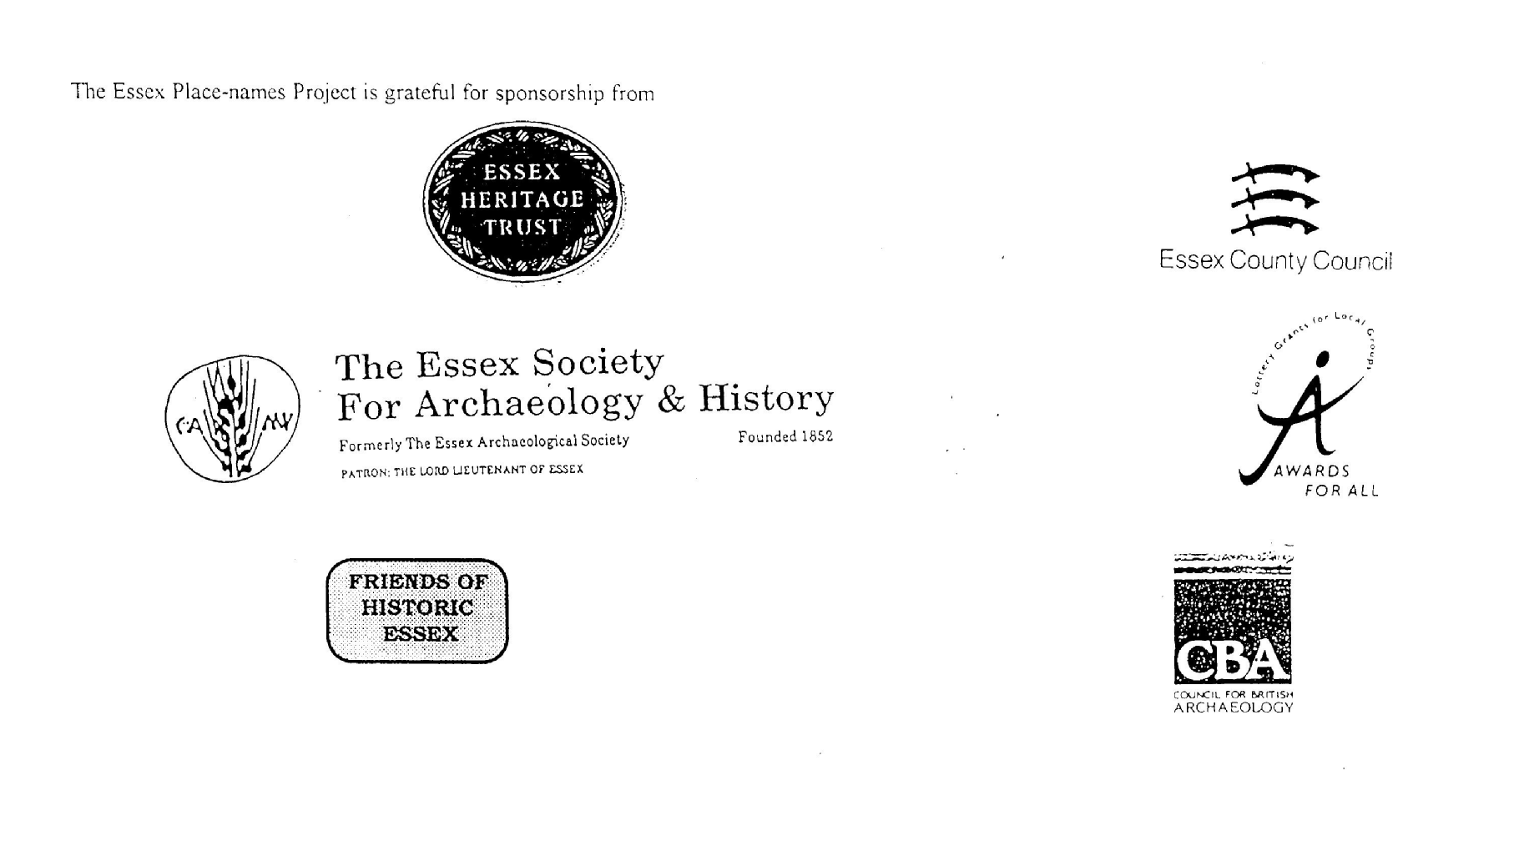

ESSEX PLACE-NAMES PROJECT.

The Essex Place-names Project is a County-wide survey to record place- and field-names from historical documents such as Tithe maps and apportionments, estate maps, sale
and auction catalogues, conveyances, terriers, deeds, rolls, inquisitions and surveys.

The second element of the Project is to investigate on-the-ground visible remains which correspond to the Place-names for actual or potential archaeological, agricultural and industrial
sites, and to record natural (topographical) and man-made features which may relate to the Place-name. This involves field-survey in rural and outside investigation in built-up areas.

It is anticipated that the Project will lead to identification of archaeological sites and lost historic buildings; it will enable analysis of indicators of early settlement, land holding, agricultural and industrial practices of the County. It will refine the more precise meaning of descriptive words and elements used by earlier settlers as they gave names appropriate to the topography of the landscape of their time.

For convenience the surveys are based on the parish, recognising that present civil parish boundaries are not necessarily identical to former ecclesiastical boundaries. Local Recorders
are supplied with templates of Record Forms to ensure consistency of recording across the County, and forward completed forms to a Central Coordinator for transfer to a county
computer database which is available to researchers on the internet at www.essex.ac.uk/history/esah/essexplacenames, and updated periodically.

This publication presents part of the information recorded from the Tithe or Estate Award and Map, and from other documents for this parish. The full record is contained on the master
database at Essex County Council (Historic Environment Section) and on the (above) website. Parish books are available from the Publications Manager, Essex Record Office, Wharf Road, Chelmsford CM2 6YT, on disc or in hard copy or may be downloaded from the website link ‘Books’ on the Home page. Please notify errors to the Project Coordinator at the Essex Record Office.

THE TITHE MAP AND APPORTIONMENT.

Since medieval times a tenth of the produce of land and stock had been paid by landholders to the church. At the Dissolution of the Monasteries, the property of many religious houses,
including the right to collect tithes, passed into lay hands. The Tithe Commutation Act which received Royal assent on 13th August 1836 abolished a rent payable in kind and
substituted rent-charges apportioned on each plot or parcel. The tithe-rent payable was assessed on the average value of wheat, barley and oats and was to fluctuate with price movements.

The commutation could be by voluntary agreement between the local owners and payers or, if agreement failed, could be compulsorily imposed by commissioners. A Valuer was to be
appointed to apportion the rent of each parcel of land and tenants could deduct that rent-charge from their rent paid to the landlord. The task fell to the Tithe Commissioners to produce a
map and an Apportionment (Award). A large-scale survey was produced for over 70% of England and Wales in the following 9 years, and about another 8% up to 1855. Most of the
parishes in Essex were surveyed. The map scales vary. The Award records ownership, tenancy and land-use, field by field and parcel by parcel (often quoting the field name) with the
ground area and rent-charge.

Land that was tithe-free tends to be less accurately mapped and contains few if any of the details recorded for those parcels subject to tithe. Rights of way and roads also tend to be
neglected. Boundaries of the tithe areas are shown as are some natural features such as streams, ponds, gardens, greens and commons. Buildings are often shown coloured red if dwellings
or grey if not. Because the Award may have been agreed only some time after the map was finished, discrepancies occur between the two. Enclosure Awards, when extant, usually date to the 18th and early 19th centuries. J.Kemble.
Reproduced by permission
of Essex County Council.

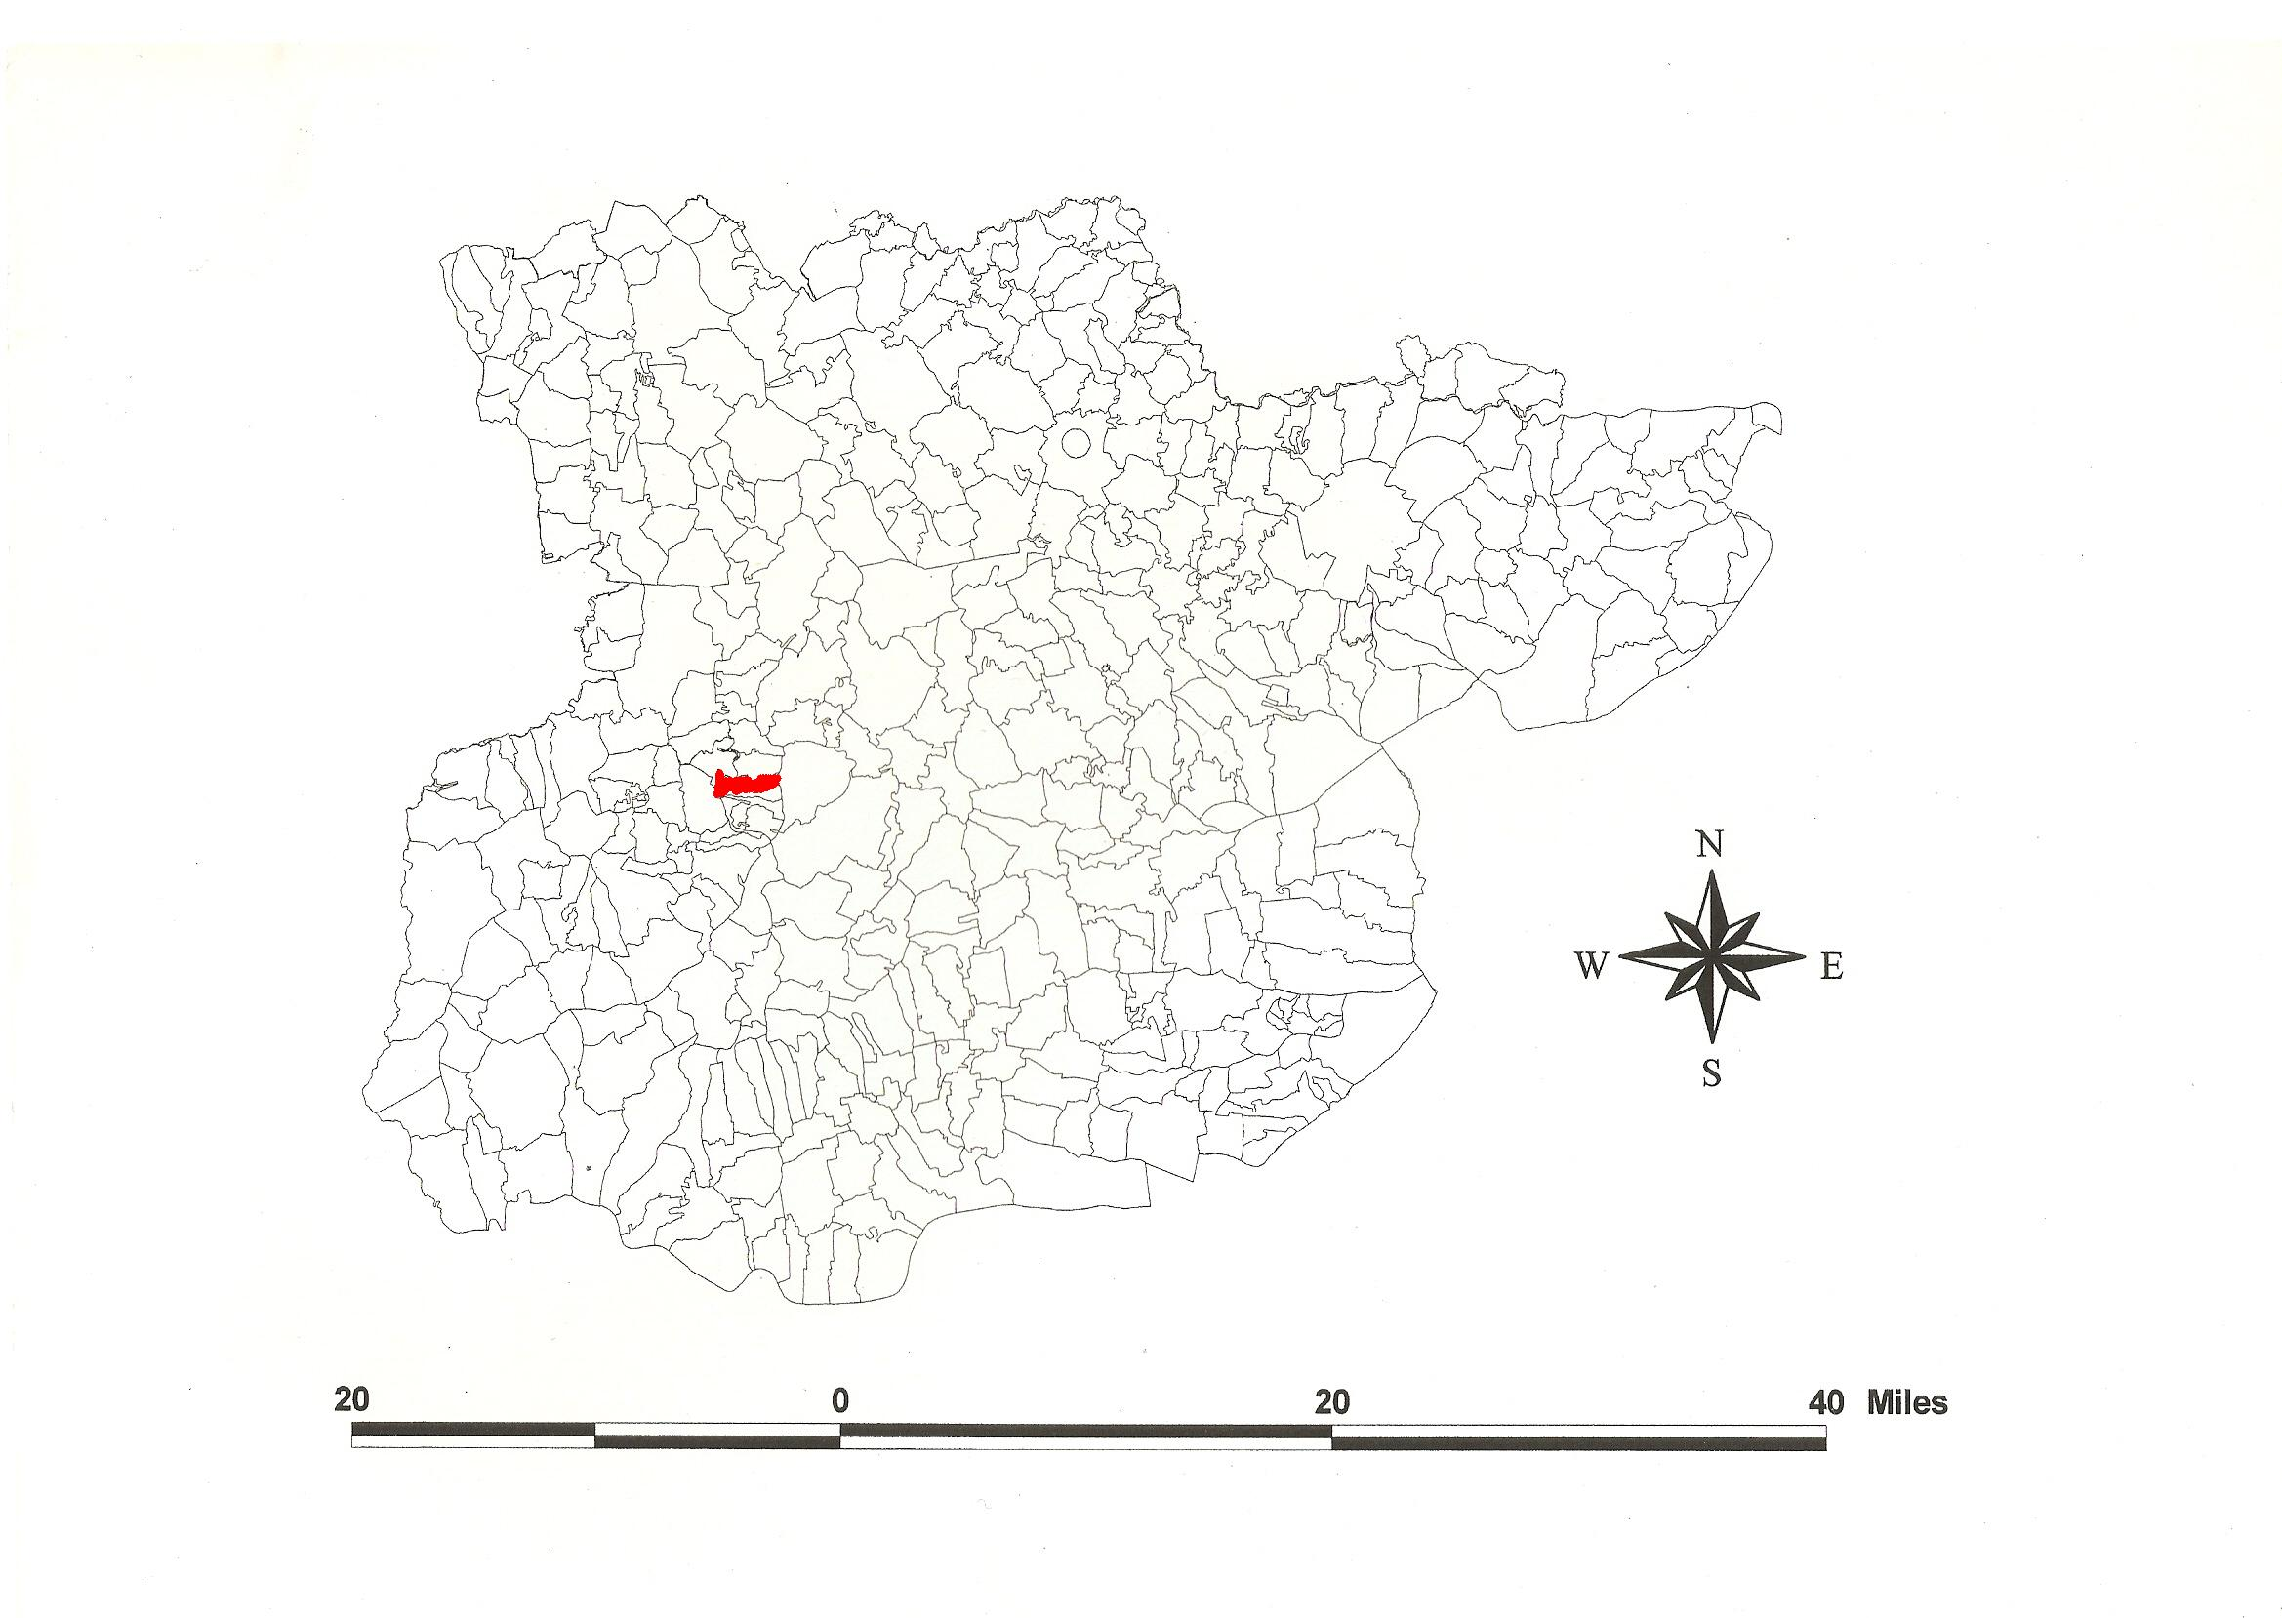
Reproduced by permission of Essex County Council.
The Parish of Willingale Doe in the County of Essex.

The Parish of Willingale Doe (in Dunmow Hundred).

The Tithe Award of Willingale Doe (Essex Record Office D/CT 402a), dated 1837, shows a rent-charge of £500 to John Deedes, rector, including glebe of £10-15-0. The whole parish measured 1755 acres of which subject to Tithes were 1726 acres 1 rood 9 perches. Arable were 1382a 3r 32p, meadow and pasture 335a 2r 39p, wood 7a 2r 18p, glebe 31a 32p and glebe
of Shellow Bowells 12a 1r 4p. The Tithe Commissioners were William Blamire & R. Jones, the Valuer Edward Corfield of Keppel Street Blooomsbury, Middlesex. The Tithe Map (ERO: D/CT 402b) was surveyed at a scale of 3 chains to one inch (26.6” to a mile) and measures 80”x86”. It was countersigned by J.M. Mathew, Assistant Tithe Commissioner.

In Domesday Book, 1086, Warner held Willingehala(m) from Earl Swein, sheriff of Essex sometime between 1066 and 1086, which a free man had held before 1066 for 20 acres. Raventot held Willingehala(m) from Ranulf Peveral which Siward had held before 1066 as a manor for one hide 1½ virgates. Five free men held Willinghehala before 1066 as a manor for half a hide which was land of Adam son of Durand Malzor in 1086. Swein’s and Adam’s holdings are unlocated to Willingale Doe or Spain. Watts (2004) translates this from an Old English personal name + halh, ‘the people called after Willa + nook’. Wylingeshale Doe is recorded in 1270 and Doo in 1328 from Hugh de Ou or D’eu from Seine Maritime, earlier, in 1254, Rokele from Philip de la Rokele, 1198 (Feet Fine) (Reaney, 1935; Kemble, 2007). Bernard held Plesinchov from Count Eustace of Boulogne, brother-in-law of King Edward, which a free man had held before 1066 for half a hide. In Plesinchov a free man held one hide which Humfrid aurei testiculi annexed in the king’s despite; formerly there was a mill. This is O.E. hoh, ‘ridge of Plesa’, perhaps at Miller’s Green by Torrell’s Hall (Round, J.; Reaney, 1935; Morris, 1983).

There were two manors. 1. Wardons Hall, half a mile southwest of the church. William de Wanton (died 1347) held it of Maurice de Brune for one knight’s fee. His son William died 1393. t.Stephen (1135-1154) it was with William d’Ou. 2. Torells Hall was taken out of Wardons, one mile northeast of the church. Richard Torell (died 1404) held two parts of Shellow. Thomas Torell of Willingale Doe was sheriff of Essex 6Henry VI (1427/8) (Morant, 1768).

The church dedicated to St Christopher, extensively restored in 1852-3, has a 14th century chancel and nave, and rebuilt 15th century tower. The Old Rectory, late 18th century, is moated. Dukes farmhouse has a hall and two jettied cross-wings, 16th century. Warden’s Hall has 5 bays, two storeys, c.1720-40. Torrell’s Hall, late 16th century, is of gault brick with a Doric porch (Pevsner, 2007).

The Hundred name in 1086 was variably Dom(m)auua and Dunham (Domesday Book and Inquisitio Eliensis), from O.E. dun and mawe, ‘hill meadow(s)’. Christy (1926) points out that three Roman roads meet in (Great) Dunmow in which parish the moot was probably situated. In 942x951 Theodred, bishop of London, willed his estate at Dunemowe to St Paul’s. In c.995x998 Dunmæwan with Tolleshunt was required by St Paul’s to provide one man for ship-duty against incursions (Hart, 1971; Kemble, 2007). Thurstan, husband of the great-granddaughter of earldorman Brihtnoth who died at the Battle of Maldon in 991, willed the estate at Dunmawe (Little Dunmow) to Merewine and his wife (Whitelock, 1930).

Place- and field-names from other documents are included adjacent to the Tithe Award names. For further field-names of Willingale see Lamb, 2005, and Kemble, 2013.

References:
Christy, M., 1926. The Essex Hundred Moots. Trans Essex Archaeological Society, ns xviii(3), 192.
Hart, C., 1981. Early Charters of Essex. Leicester.
Kemble, J., 2007. Essex Place-names, Places, Streets & People. Historical Publications, London. pp 10, 91.
Kemble, J., 2013. The Place-names of Willingale Spain. www.essex.ac.uk/history/esah/essexplacenames. Then click on ‘Books’.
Lamb, E., 2005. Survey of Blake Hall, Bobbingworth, Essex Record Office. www.essex.ac.uk/history/esah/essexplacenames.
Morant, P., 1768. History & Antiquities of the County of Essex. ii, 477.
Morris, J., 1983. Domesday Book – Essex. Phillimore.
Pevsner, N., Bettley, J., 2007. Buildings of England – Essex. Yale.
Reaney, P., 1935. Place-names of Essex. Cambridge.
Round, J., Essex Archaeology & History, ns., viii, 333-4, 376.
Whitelock, D., 1930. Anglo-Saxon Wills. Cambridge.

The Tithe Award Place-names of Willingale Doe - by Parcel No.

Place-name | Alias | Fld No | Grd Ref | x | y | Acr | rd | pch | land use | Owner | Occupier | Farm | Other information
Willingale field |  | 1 | TL | 582 | 095 | 10 | 3 | 2 | arable | Bridges, William | Pemberton, Joseph | Gubbis
Stable Hoppet, pt of stables |  | 2 | TL | 581 | 094 | 0 | 2 | 12 | grass | Bridges, William | Pemberton, Joseph | Gubbis
Small Gains |  | 3 | TL | 582 | 094 | 1 | 2 | 1 | arable | Bridges, William | Pemberton, Joseph | Gubbis
Oakley Hoppet |  | 4 | TL | 582 | 093 | 1 | 3 | 27 | grass | Bridges, William | Pemberton, Joseph | Gubbis
East house field (pt) |  | 5 | TL | 581 | 093 | 3 | 2 | 13 | arable | Bush, William | Bush, William | Hornetts
Rick yard |  | 6 | TL | 581 | 093 | 0 | 1 | 34 |  | Bridges, William | Pemberton, Joseph | Gubbis
Dove House Hoppet (pt) |  | 7 | TL | 581 | 092 | 1 | 2 | 23 | grass | Bridges, William | Pemberton, Joseph | Gubbis
Dove House Field (pt) |  | 8 | TL | 581 | 092 | 2 | 0 | 27 | arable | Bridges, William | Pemberton, Joseph | Gubbis
High field |  | 9 | TL | 582 | 092 | 21 | 3 | 7 | arable | Bush, William | Bush, William | Hornetts
Gubbis mead |  | 10 | TL | 583 | 091 | 3 | 0 | 19 | grass | Bush, William | Bush, William | Hornetts | Robert de Guppey, 1331,FF
Long mead |  | 11 | TL | 583 | 090 | 2 | 0 | 28 | grass | Bush, William | Bush, William | Hornetts
Kitchen mead (pt) |  | 12 | TL | 585 | 091 | 1 | 1 | 12 | grass | Bush, William | Bush, William | Hornetts
Stringlands |  | 13 | TL | 586 | 091 | 9 | 3 | 25 | arable | Bush, William | Bush, William | Hornetts
Diggins mead |  | 14 | TL | 585 | 090 | 1 | 3 | 31 | grass | Dodd, Cornelius | Dodd, Cornelius | Birds Green
Kitchen mead |  | 15 | TL | 586 | 090 | 1 | 0 | 35 | grass | Dodd, Cornelius | Dodd, Cornelius | Birds Green
Yard, orchard (pt) | [at Birds Green, 1875,OS] | 16 | TL | 586 | 089 | 1 | 1 | 4 | grass | Dodd, Cornelius | Dodd, Cornelius | Birds Green
Homestead | cp. Burdesgrene hamlett, 1563,EAS xii | 17 | TL | 586 | 089 | 0 | 1 | 29 |  | Dodd, Cornelius | Dodd, Cornelius | Birds Green | Robert Brid, 1285,Ass
Orchard |  | 18 | TL | 586 | 090 | 2 | 0 | 36 |  | Dodd, Cornelius | Dodd, Cornelius | Birds Green
Birds Green Ley |  | 21 | TL | 586 | 087 | 5 | 3 | 8 | grass | Fordham, John | Fordham, John | Diggens
Ten acres |  | 22 | TL | 586 | 087 | 12 | 1 | 32 | arable | Fordham, John | Fordham, John | Diggens
Twelve acres |  | 23 | TL | 583 | 085 | 13 | 1 | 35 | arable | Fordham, John | Fordham, John | Diggens
Nine acres |  | 24 | TL | 584 | 085 | 10 | 2 | 10 | arable | Fordham, John | Fordham, John | Diggens
Long mead |  | 25 | TL | 584 | 083 | 7 | 1 | 3 | grass | Fordham, John | Fordham, John | Diggens
Little mead |  | 26 | TL | 583 | 083 | 1 | 3 | 7 | grass | Fordham, John | Fordham, John | Diggens
Little High field (pt) |  | 27 | TL | 581 | 082 | 3 | 0 | 18 | arable | Fordham, John | Fordham, John | Diggens
Eight acres |  | 28 | TL | 579 | 081 | 9 | 2 | 12 | arable | Fordham, John | Fordham, John | Diggens
Serpentine mead |  | 29 | TL | 580 | 081 | 7 | 0 | 9 | grass | Fordham, John | Fordham, John | Diggens
The Hoppet |  | 30 | TL | 581 | 081 | 1 | 0 | 25 | grass | Fordham, John | Fordham, John | Diggens
The Stack Yard |  | 31 | TL | 582 | 081 | 0 | 0 | 30 |  | Fordham, John | Fordham, John | Diggens
Homestead | Diggings, 1777,C; Diggins,1875,OS | 32 | TL | 582 | 081 | 2 | 2 | 12 |  | Fordham, John | Fordham, John | Diggens | moated
Carthouse field |  | 33 | TL | 583 | 082 | 12 | 0 | 19 | arable | Fordham, John | Fordham, John | Diggens
Parkers |  | 34 | TL | 585 | 082 | 7 | 2 | 33 | arable | Fordham, John | Fordham, John | Diggens
Reeves field |  | 35 | TL | 585 | 081 | 8 | 3 | 33 | arable | Fordham, John | Fordham, John | Diggens
Front mead |  | 36 | TL | 583 | 081 | 10 | 1 | 35 | grass | Fordham, John | Fordham, John | Diggens
Spring field |  | 37 | TL | 578 | 080 | 11 | 0 | 33 | arable | Fordham, John | Fordham, John | Diggens
Square field |  | 38 | TL | 577 | 080 | 9 | 3 | 39 | arable | Fordham, John | Fordham, John | Diggens
Long field |  | 39 | TL |  |  | 7 | 3 | 10 | arable | Fordham, John | Fordham, John | Diggens
Field behind Leys |  | 40 | TL | 577 | 078 | 8 | 0 | 13 | arable | Dacre, Lord | Ash, William | Pickerils
Two acre piece near Pickerils |  | 41 | TL | 577 | 078 | 2 | 1 | 34 | arable | Shipton, William | Shipton, William | .
Slipe |  | 42 | TL |  |  | 1 | 1 | 20 | arable | Arbrey, William | Claydon, Robert | Peters Land
Barn & yard |  | 45 | TL | 578 | 078 | 0 | 1 | 11 |  | Arbrey, William | Claydon, Robert | Peters Land
Home field |  | 46 | TL | 578 | 078 | 4 | 1 | 25 | arable | Arbrey, William | Claydon, Robert | Peters Land
Five acres |  | 47 | TL |  |  | 4 | 2 | 37 | arable | Arbrey, William | Claydon, Robert | Peters Land
Knockley field |  | 48 | TL |  |  | 15 | 3 | 27 | arable | Dacre, Lord | Ash, William | Pickerils
Knockley field (pt) |  | 49 | TL | 582 | 077 | 2 | 3 | 5 | grass | Dacre, Lord | Ash, William | Pickerils
Two Hoppets at Gang Bridge |  | 50 | TL | 581 | 077 | 0 | 1 | 22 | grass | Shipton, William | Shipton, William | .
Wood pieces |  | 51 | TL |  |  | 9 | 1 | 26 | arable | Dacre, Lord | Ash, William | Pickerils
First Long Mead |  | 52 | TL |  |  | 4 | 1 | 16 | grass | Dacre, Lord | Ash, William | Pickerils
Second Long Mead |  | 53 | TL |  |  | 2 | 1 | 7 | grass | Dacre, Lord | Ash, William | Pickerils
Gang Bridge mead (pt) |  | 54 | TL | 583 | 077 | 2 | 1 | 6 | grass | Brockett, Stanes Brockett esq | Surridge, Jesse | Hill Farm (pt)
Back field (pt) |  | 55 | TL |  |  | 5 | 1 | 24 | arable | Brockett, Stanes Brockett esq | Surridge, Jesse | Hill Farm (pt)
Homestead | Hill Farm, 1875,OS | 56 | TL | 586 | 075 | 0 | 2 | 30 |  | Brockett, Stanes Brockett esq | Surridge, Jesse | Hill Farm (pt)
Front field |  | 57 | TL | 587 | 077 | 6 | 0 | 20 | arable | Brockett, Stanes Brockett esq | Surridge, Jesse | Hill Farm (pt)
Gang Bridge Mead |  | 58 | TL | 582 | 078 | 1 | 1 | 5 | grass | Shipton, William | Shipton, William | .
Hither Gang Bridge mead |  | 59 | TL | 584 | 079 | 4 | 0 | 38 | arable | Dacre, Lord | Ash, William | Pickerils
Further Gang Bridge mead (pt) |  | 60 | TL |  |  | 3 | 1 | 1 | grass | Dacre, Lord | Ash, William | Pickerils
Standford piece |  | 61 | TL |  |  | 12 | 1 | 34 | arable | Dacre, Lord | Ash, William | Pickerils
Bear field |  | 63 | TL | 586 | 082 | 19 | 3 | 27 | grass | Dacre, Lord | Ash, William | Pickerils
Lot in Common Mead |  | 64 | TL |  |  | 0 | 2 | 9 | grass | Brockett, Stanes Brockett esq | Judd, John | .
In Common Mead |  | 65 | TL |  |  | 1 | 2 | 19 | grass | Dodd, Cornelius | Dodd, Cornelius | Birds Green
In Common Mead |  | 66 | TL | 586 | 085 | 0 | 1 | 36 | grass | Dodd, Cornelius | Dodd, Cornelius | Birds Green
Little Valentine's field |  | 67 | TL | 585 | 083 | 3 | 1 | 23 | arable | Fordham, John | Fordham, John | Diggens
Cottage, orchard |  | 68-9 | TL |  |  | 0 | 3 | 15 |  | Horsenail, Samuel | Horsenail, Samuel | .
Hither Common mead |  | 70 | TL | 587 | 086 | 1 | 1 | 27 | grass | Bramston, Thomas Wm esq | Dodd, Cornelius | .
Little Miles Mead or Church Pasture |  | 71 | TL | 586 | 084 | 0 | 2 | 39 | grass | Willingale Doe, parish officers | Dodd, Cornelius | .
Hither Meadow |  | 73 | TL |  |  | 1 | 3 | 15 | grass | Brockett, Stanes Brockett esq | Barnard | Elms (pt)
Short Trenches |  | 74 | TL | 590 | 088 | 10 | 1 | 7 | arable | Brockett, Stanes Brockett esq | Barnard | Elms (pt)
Long Trenches Meadow |  | 75 | TL | 589 | 088 | 1 | 3 | 10 | grass | Brockett, Stanes Brockett esq | Barnard | Elms (pt)
Bakers mead |  | 76 | TL | 588 | 087 | 0 | 3 | 27 | grass | Baker, Thomas | Baker, Thomas | Bakers
Long Trenches |  | 77 | TL | 590 | 087 | 14 | 2 | 23 | arable | Brockett, Stanes Brockett esq | Barnard | Elms (pt)
Upper Pluckendon |  | 78 | TL | 591 | 084 | 15 | 3 | 7 | arable | Death, William, esq | Death, Woodham | Dukes
Lower Pluckendon |  | 79 | TL | 589 | 084 | 19 | 2 | 20 | arable | Death, William, esq | Death, Woodham | Dukes
Meadow |  | 80 | TL | 588 | 084 | 2 | 3 | 33 | grass | Baker, Thomas | Baker, Thomas | Bakers
Four & half acres |  | 81 | TL | 590 | 082 | 5 | 1 | 3 | arable | Baker, Thomas | Baker, Thomas | Bakers
Upper Back field |  | 82 | TL | 591 | 082 | 9 | 3 | 11 | arable | Death, William, esq | Death, Woodham | Dukes
Pit |  | 83 | TL |  |  | 0 | 0 | 15 | wood | Baker, Thomas | Baker, Thomas | Bakers
Barn yards etc |  | 84 | TL |  |  | 0 | 1 | 16 |  | Baker, Thomas | Baker, Thomas | Bakers
Acre piece |  | 84a | TL |  |  | 1 | 0 | 13 | arable | Baker, Thomas | Baker, Thomas | Bakers
Lower Back field |  | 87 | TL | 591 | 080 | 9 | 1 | 0 | arable | Death, William, esq | Death, Woodham | Dukes
Homestead | Dukes, 1777,C | 89 | TL | 596 | 080 | 1 | 0 | 10 |  | Death, William, esq | Death, Woodham | Dukes | William Duke of Shellow, 1381,SR
Meadow |  | 90 | TL |  |  | 5 | 3 | 34 | grass | Death, William, esq | Death, Woodham | Dukes
Old Clerks field |  | 91 | TL | 597 | 080 | 6 | 3 | 29 | arable | Bramston, Rev John | Taylor, Joseph | Torrells Hall (pt)
Clerks mead |  | 92 | TL | 599 | 080 | 7 | 1 | 9 | grass | Bramston, Rev John | Taylor, Joseph | Torrells Hall (pt)
Long meadow |  | 93 | TL |  |  | 7 | 1 | 29 | grass | Bramston, Rev John | Taylor, Joseph | Torrells Hall (pt)
The Lawn & chaseway |  | 94 | TL |  |  | 2 | 2 | 39 | grass | Bramston, Rev John | Taylor, Joseph | Torrells Hall (pt)
Homestead | Torrell's Hall, 1875,OS | 95 | TL | 600 | 084 | 2 | 1 | 0 |  | Bramston, Rev John | Taylor, Joseph | Torrells Hall (pt) | Thomas Torell, 1427,Morant
Garden |  | 96 | TL |  |  | 0 | 3 | 36 |  | Bramston, Rev John | Taylor, Joseph | Torrells Hall (pt)
Long mead |  | 97 | TL | 682 | 082 | 7 | 1 | 31 | grass | Bramston, Rev John | Taylor, Joseph | Torrells Hall (pt)
Mill Mead |  | 98 | TL | 602 | 080 | 7 | 0 | 28 | grass | Bramston, Rev John | Taylor, Joseph | Torrells Hall (pt)
Brickland mead |  | 99 | TL | 601 | 080 | 6 | 3 | 16 | grass | Bramston, Rev John | Taylor, Joseph | Torrells Hall (pt)
Little Hall field |  | 100 | TL | 603 | 083 | 7 | 1 | 15 | arable | Bramston, Rev John | Taylor, Joseph | Torrells Hall (pt)
Great Hall field |  | 101 | TL | 604 | 084 | 13 | 3 | 28 | arable | Bramston, Rev John | Taylor, Joseph | Torrells Hall (pt)
Brewhouse mead |  | 102 | TL | 602 | 083 | 4 | 2 | 17 | grass | Bramston, Rev John | Taylor, Joseph | Torrells Hall (pt)
Orchard mead |  | 103 | TL | 599 | 082 | 3 | 1 | 20 | grass | Bramston, Rev John | Taylor, Joseph | Torrells Hall (pt)
Coach house field |  | 104 | TL | 599 | 081 | 14 | 0 | 22 | arable | Bramston, Rev John | Taylor, Joseph | Torrells Hall (pt)
Great Potash field |  | 105 | TL | 598 | 084 | 4 | 0 | 4 | grass | Bramston, Rev John | Taylor, Joseph | Lodge Farm (pt)
Great Lodge field |  | 106 | TL | 596 | 085 | 26 | 2 | 2 | arable | Bramston, Rev John | Taylor, Joseph | Lodge Farm (pt)
Lower Park field |  | 107 | TL | 593 | 082 | 20 | 1 | 0 | arable | Bramston, Rev John | Taylor, Joseph | Lodge Farm (pt)
Middle Park field |  | 108 | TL | 593 | 084 | 19 | 1 | 3 | arable | Bramston, Rev John | Taylor, Joseph | Lodge Farm (pt)
Upper Park field |  | 109 | TL | 593 | 086 | 13 | 2 | 18 | arable | Bramston, Rev John | Taylor, Joseph | Lodge Farm (pt)
Water house field |  | 111 | TL | 593 | 087 | 3 | 1 | 38 | arable | Barlow, William | Judd, John | .
Cross Croft |  | 112 | TL | 594 | 089 | 3 | 2 | 2 | arable | Brockett, Stanes Brockett esq | Barnard | Elms (pt)
Broad field |  | 113 | TL | 597 | 089 | 20 | 2 | 3 | arable | Brockett, Stanes Brockett esq | Barnard | Elms (pt)
Cart Lodge field |  | 114 | TL | 596 | 087 | 16 | 0 | 18 | arable | Bramston, Rev John | Taylor, Joseph | Lodge Farm (pt)
Farm Homestead | The Lodge, 1777,C; Lodge Farm, 1875,OS | 115 | TL | 597 | 086 | 1 | 1 | 25 |  | Bramston, Rev John | Taylor, Joseph | Lodge Farm (pt)
Lodge Ley |  | 116 | TL | 600 | 085 | 8 | 3 | 5 | grass | Bramston, Rev John | Taylor, Joseph | Lodge Farm (pt)
Lower Potash mead |  | 117 | TL |  |  | 1 | 3 | 35 | grass | Bramston, Rev John | Taylor, Joseph | Lodge Farm (pt)
Walnut tree field |  | 118 | TL |  |  | 4 | 1 | 33 | arable | Bramston, Rev John | Taylor, Joseph | Torrells Hall (pt)
Square pond field |  | 119 | TL | 601 | 084 | 7 | 2 | 16 | arable | Bramston, Rev John | Taylor, Joseph | Torrells Hall (pt)
Four Acres |  | 120 | TL | 601 | 085 | 4 | 3 | 7 | arable | Bramston, Rev John | Taylor, Joseph | Lodge Farm (pt)
Stable field |  | 121 | TL | 599 | 087 | 8 | 1 | 1 | arable | Bramston, Rev John | Taylor, Joseph | Lodge Farm (pt)
Old Redding |  | 123 | TL | 602 | 085 | 10 | 1 | 8 | arable | Bramston, Rev John | Taylor, Joseph | Torrells Hall (pt)
Roundabout field |  | 126 | TL | 604 | 085 | 6 | 2 | 30 | arable | Bramston, Rev John | Taylor, Joseph | Torrells Hall (pt)
Eleven acres on Manchester field |  | 127 | TL | 608 | 087 | 13 | 1 | 12 | arable | Bramston, Thomas Wm, esq | Bramston, Thomas Wm, esq | Rowes
Long croft (pt) |  | 129 | TL | 610 | 088 | 2 | 3 | 6 | arable | Bramston, Thomas Wm, esq | Bramston, Thomas Wm, esq | Rowes
Ley (pt) |  | 130 | TL | 611 | 088 | 3 | 3 | 18 | grass | Bramston, Thomas Wm, esq | Bramston, Thomas Wm, esq | Rowes
Eight acres (pt) |  | 131 | TL | 612 | 088 | 4 | 2 | 18 | arable | Bramston, Thomas Wm, esq | Bramston, Thomas Wm, esq | Rowes
Thistle down (pt) | Thisteldownes lande, tHenryVIII,Srvy | 132 | TL | 613 | 089 | 7 | 1 | 5 | arable | Bramston, Thomas Wm, esq | Bramston, Thomas Wm, esq | Rowes
Buncocks (pt) |  | 133 | TL | 615 | 620 | 6 | 3 | 16 | arable | Bramston, Thomas Wm, esq | Bramston, Thomas Wm, esq | Rowes
Skreens Wood (pt) |  | 134 | TL | 616 | 090 | 0 | 0 | 5 |  | Bramston, Thomas Wm, esq | Bramston, Thomas Wm, esq | Rowes
Wood field |  | 135 | TL | 614 | 088 | 14 | 0 | 14 | arable | Bramston, Thomas Wm, esq | Bramston, Thomas Wm, esq | Rowes
Hedgehey Field |  | 136 | TL | 615 | 087 | 6 | 2 | 1 | arable | Bramston, Thomas Wm, esq | Bramston, Thomas Wm, esq | Rowes
Rowes Wood | Rowe's Wood, 1875,OS | 137 | TL | 613 | 086 | 4 | 3 | 25 | wood | Arbrey, William | Arbrey, William | Woodlands
Mill field | Mellefelde, tHenryVIII,Srvy | 138 | TL | 612 | 085 | 12 | 1 | 27 | arable | Bramston, Thomas Wm, esq | Bramston, Thomas Wm, esq | Rowes
Barn field |  | 139 | TL |  |  | 3 | 2 | 16 | arable | Bramston, Thomas Wm, esq | Bramston, Thomas Wm, esq | Rowes
Farm Homestead | Rouse, 1777,C; Rowe's Farm, 1875,OS | 140 | TL | 612 | 089 | 2 | 0 | 1 |  | Bramston, Thomas Wm, esq | Bramston, Thomas Wm, esq | Rowes | Matilda le Rous, 1340,Cl
Church field |  | 141 | TL | 610 | 087 | 8 | 3 | 26 | arable | Bramston, Thomas Wm, esq | Bramston, Thomas Wm, esq | Rowes
Six acres |  | 142 | TL | 610 | 085 | 7 | 0 | 16 | arable | Bramston, Thomas Wm, esq | Patmore, William | Windmill Farm
Heron field |  | 143 | TL | 609 | 084 | 10 | 2 | 30 | arable | Bramston, Thomas Wm, esq | Patmore, William | Windmill Farm
Rowes pasture |  | 144 | TL |  |  | 0 | 2 | 12 | grass | Bramston, Thomas Wm, esq | Patmore, William | Windmill Farm
Rowes field |  | 145 | TL | 607 | 083 | 18 | 1 | 26 | arable | Bramston, Thomas Wm, esq | Patmore, William | Windmill Farm
Long croft |  | 146 | TL |  |  | 3 | 2 | 31 | arable | Bramston, Thomas Wm, esq | Patmore, William | Windmill Farm
Jack Eaves |  | 147 | TL | 604 | 081 | 6 | 1 | 12 | arable | Bramston, Rev John | Taylor, Joseph | Torrells Hall (pt)
Barn field |  | 148 | TL | 605 | 081 | 4 | 3 | 38 | arable | Bramston, Thomas Wm, esq | Patmore, William | Windmill Farm
Hoppet |  | 149 | TL |  |  | 1 | 2 | 14 | grass | Bramston, Thomas Wm, esq | Patmore, William | Windmill Farm
Homestead | Gardeners, 1777,C; Windmill Farm, 1875,OS | 150 | TL | 605 | 080 | 1 | 1 | 6 |  | Bramston, Thomas Wm, esq | Patmore, William | Windmill Farm
Mill field |  | 151 | TL | 605 | 079 | 9 | 0 | 36 | arable | Bramston, Thomas Wm, esq | Patmore, William | Windmill Farm
The Windmill & plot | Willingale Mill (Corn), 1875,OS | 152 | TL | 605 | 080 | 0 | 0 | 27 |  | Harris, John | Dawson, Samuel | .
Stable mead |  | 153 | TL | 608 | 080 | 6 | 2 | 15 | grass | Bramston, Thomas Wm, esq | Patmore, William | Windmill Farm
Stable field |  | 154 | TL | 609 | 080 | 6 | 2 | 15 | arable | Bramston, Thomas Wm, esq | Patmore, William | Windmill Farm
Middle field |  | 155 | TL |  |  | 2 | 2 | 8 | grass | Bramston, Thomas Wm, esq | Patmore, William | Windmill Farm
Upper pasture |  | 156 | TL |  |  | 3 | 1 | 28 | grass | Bramston, Thomas Wm, esq | Patmore, William | Windmill Farm
Perry field | Peryfelde, tHenryVIII,Srvy | 157 | TL | 610 | 082 | 10 | 3 | 34 | arable | Bramston, Thomas Wm, esq | Patmore, William | Windmill Farm
Great High field |  | 157a | TL | 611 | 081 | 8 | 1 | 15 | arable | Bramston, Thomas Wm, esq | Patmore, William | Windmill Farm
Little Goldings |  | 158 | TL | 610 | 084 | 3 | 2 | 24 | grss, arble | Bramston, Thomas Wm, esq | Patmore, William | Windmill Farm
Great Goldings |  | 160 | TL | 611 | 084 | 9 | 2 | 8 | arable | Bramston, Thomas Wm, esq | Patmore, William | Windmill Farm
Wood field |  | 161 | TL | 613 | 085 | 8 | 2 | 15 | arable | Bramston, Thomas Wm, esq | Patmore, William | Windmill Farm
Shaw Wood |  | 162 | TL |  |  | 0 | 2 | 9 | wood | Quare, Mr Daniel | Perry, John | Bow Years
Park mead |  | 163 | TL |  |  | 2 | 1 | 3 | grass | Quare, Mr Daniel | Perry, John | Bow Years
Park field |  | 164 | TL |  |  | 6 | 0 | 28 | arable | Quare, Mr Daniel | Perry, John | Bow Years
Barn field |  | 165 | TL |  |  | 3 | 3 | 37 | arable | Quare, Mr Daniel | Perry, John | Bow Years
Long Leys |  | 166 | TL |  |  | 10 | 1 | 15 | arable | Quare, Mr Daniel | Perry, John | Bow Years
Farm Homestead | [at Curriors Green, 1777,C; Quires Green, 1875,OS] | 168 | TL | 615 | 071 | 0 | 3 | 29 |  | Quare, Mr Daniel | Perry, John | Bow Years
Hoppet |  | 169 | TL |  |  | 0 | 3 | 1 | grass | Quare, Mr Daniel | Perry, John | Bow Years
Great Field |  | 170 | TL |  |  | 10 | 2 | 3 | arable | Bramston, Thomas Wm, esq | Gardener, Johannah | Shellow Cross Farm (pt)
Garden piece |  | 171 | TL |  |  | 0 | 3 | 9 | arable | Quare, Mr Daniel | Perry, John | Bow Years
Hoppet |  | 173 | TL |  |  | 1 | 3 | 12 | grass | Quare, Mr Daniel | Perry, John | Bow Years
Middle & Further Fields | [at Brambles Green, 1875,OS] | 174 | TL | 613 | 070 | 5 | 1 | 16 | arable | Quare, Mr Daniel | Perry, John | Bow Years
Kitchen field |  | 175 | TL | 612 | 068 | 5 | 3 | 8 | arable | Bramston, Thomas Wm, esq | Lucking, James | Luckings
Field adj. Tumbler's Green |  | 176 | TL | 615 | 071 | 6 | 3 | 3 | arable | Bramston, Thomas Wm, esq | Lucking, James | Late Walls
Second Field |  | 178 | TL |  |  | 1 | 2 | 2 | grass | Bramston, Thomas Wm, esq | Lucking, James | Late Walls
Kitchen field |  | 179 | TL |  |  | 7 | 0 | 27 | arable | Bramston, Thomas Wm, esq | Campion | Pooty Pool
One & half Acre field |  | 180 | TL |  |  | 1 | 3 | 32 | arable | Bramston, Thomas Wm, esq | Lucking, James | Catch Drakes
Hoppet |  | 181 | TL |  |  | 1 | 1 | 13 | grass | Bramston, Thomas Wm, esq | Campion | Pooty Pool
Barn field barn etc |  | 182 | TL |  |  | 5 | 3 | 23 | arable | Bramston, Thomas Wm, esq | Lucking, James | Late Walls
Haycock field |  | 183 | TL |  |  | 3 | 2 | 18 | arable | Bramston, Thomas Wm, esq | Lucking, James | Late Walls
Fast Meadow |  | 184 | TL |  |  | 1 | 1 | 29 | grass | Bramston, Thomas Wm, esq | Lucking, James | Late Walls
Barn croft |  | 185 | TL |  |  | 5 | 3 | 9 | arable | Bramston, Thomas Wm, esq | Lucking, James | Luckings
Hoppet |  | 186 | TL |  |  | 0 | 2 | 27 | grass | Bramston, Thomas Wm, esq | Lucking, James | Late Walls
Hundred Acres |  | 188 | TL |  |  | 0 | 1 | 9 | grass | Bramston, Thomas Wm, esq | Lucking, James | Luckings
Barn field |  | 190 | TL |  |  | 4 | 2 | 0 | arable | Chalk, Thomas esq | Lucking, James | Late Walls (pt)
Further Hoppet |  | 193 | TL |  |  | 1 | 1 | 5 | grass | Bramston, Thomas Wm, esq | Campion | Pooty Pool
Hoppet |  | 194 | TL |  |  | 0 | 2 | 5 | grass | Bramston, Thomas Wm, esq | Lucking, James | Catch Drakes
Hither & Further Field |  | 196 | TL |  |  | 8 | 3 | 36 | arable | Bramston, Thomas Wm, esq | Lucking, James | Catch Drakes
Great Field | [at Nealls Green, 1777,C; Walls Green, 1875,OS] | 197 | TL | 618 | 065 | 8 | 1 | 16 | arable | Bramston, Thomas Wm, esq | Lucking, James | Luckings
Field below 190 | [at Marvil Green, 1777,C; Marvell Green, 1875,OS] | 199 | TL | 615 | 063 | 3 | 1 | 1 | arable | Chalk, Thomas esq | Lucking, James | Late Walls (pt)
Clap Gates |  | 200 | TL |  |  | 3 | 1 | 23 | arable | Bramston, Thomas Wm, esq | Campion | Pooty Pool
Hither Catchmans (pt) |  | 201 | TL |  |  | 2 | 3 | 37 | arable | Bramston, Thomas Wm, esq | Campion | Pooty Pool
Further Catchmans |  | 202 | TL | 616 | 062 | 3 | 3 | 4 | arable | Bramston, Thomas Wm, esq | Campion | Pooty Pool
Ten acres |  | 203 | TL |  |  | 12 | 0 | 28 | arable | Bramston, Thomas Wm, esq | Norrington, Samuel | Radley Green
Eleven acres |  | 204 | TL | 616 | 063 | 11 | 3 | 36 | arable | Bramston, Thomas Wm, esq | Norrington, Samuel | Radley Green
Long Croft or Slipe |  | 205 | TL |  |  | 1 | 2 | 27 | arable | Mead, Mrs Judith | Mead, Mrs Judith | Bassetts
Further Copyhold field |  | 206 | TL |  |  | 3 | 2 | 23 | arable | Quare, Mr Daniel | Perry, John | Bow Years
Hither Copyhold field |  | 207 | TL |  |  | 3 | 3 | 23 | arable | Quare, Mr Daniel | Perry, John | Bow Years
Hiffers |  | 208 | TL | 613 | 063 | 1 | 2 | 25 | arable | Bramston, Thomas Wm, esq | Lucking, James | Clap Gates
Rye Grass field |  | 209 | TL | 612 | 064 | 2 | 1 | 26 | grass | Bramston, Thomas Wm, esq | Lucking, James | Luckings
Farm Homestead | Clapgate, 1875,OS | 210 | TL | 615 | 068 | 0 | 2 | 34 |  | Bramston, Thomas Wm, esq | Lucking, James | Luckings
Hoppet |  | 211 | TL |  |  | 1 | 0 | 28 | grass | Bramston, Thomas Wm, esq | Lucking, James | Luckings
Percy's Hoppet |  | 212 | TL |  |  | 0 | 3 | 11 | grass | Bramston, Thomas Wm, esq | Lucking, James | Luckings
Orchard |  | 214 | TL |  |  | 0 | 1 | 32 | grass | Bramston, Thomas Wm, esq | Lucking, James | Luckings
Field behind Orchard |  | 216 | TL |  |  | 2 | 3 | 15 | arable | Bramston, Thomas Wm, esq | Lucking, James | Clap Gates
Bramble field | [at Silver Lane, 1875,OS] | 217 | TL | 611 | 069 | 9 | 2 | 38 | arable | Bramston, Thomas Wm, esq | Lucking, James | Clap Gates
Gore Field |  | 218 | TL | 613 | 070 | 8 | 3 | 16 | arable | Bramston, Thomas Wm, esq | Lucking, Samuel | Shellow Hall
Lamb Bones |  | 219 | TL | 611 | 070 | 9 | 3 | 15 | arable | Bramston, Thomas Wm, esq | Lucking, Samuel | Shellow Hall
Barn field |  | 220 | TL | 610 | 068 | 2 | 2 | 35 | arable | Bramston, Thomas Wm, esq | Lucking, James | Clap Gates
Sandfords mead |  | 221 | TL |  |  | 1 | 2 | 14 | grass | Bramston, Thomas Wm, esq | Lucking, James | Clap Gates
Barn & yard |  | 222 | TL |  |  | 0 | 0 | 19 |  | Bramston, Thomas Wm, esq | Lucking, James | Clap Gates
Four Acre Meadow |  | 224 | TL |  |  | 4 | 0 | 29 | grass | Bramston, Thomas Wm, esq | Lucking, James | Luckings
Field before Sandfords |  | 225 | TL |  |  | 4 | 1 | 9 | arable | Bramston, Thomas Wm, esq | Lucking, James | Clap Gates
Priestly field |  | 226 | TL |  |  | 3 | 0 | 5 | arable | Bramston, Thomas Wm, esq | Lucking, James | Clap Gates
Hop Ground |  | 227 | TL |  |  | 1 | 2 | 9 | arable | Chalk, Thomas esq | Lucking, James | Late Walls (pt)
Hoppet |  | 228 | TL |  |  | 1 | 0 | 25 | grass | Chalk, Thomas esq | Lucking, James | Late Walls (pt)
Four acres |  | 230 | TL | 609 | 070 | 4 | 2 | 14 | arable | Chalk, Thomas esq | Lucking, James | Late Walls (pt)
One acre piece |  | 231 | TL |  |  | 1 | 0 | 18 | arable | Cusack, Miss Louisa | Lucking, James | Sawyers
Two acres |  | 232 | TL |  |  | 2 | 2 | 3 | arable | Chalk, Thomas esq | Lucking, James | Late Walls (pt)
Long field |  | 233 | TL | 608 | 067 | 4 | 1 | 25 | arable | Chalk, Thomas esq | Lucking, James | Late Walls (pt)
Dame Perry's field |  | 234 | TL | 607 | 069 | 6 | 0 | 11 | arable | Bramston, Thomas Wm esq | Lucking, Samuel | Shellow Hall
Field opp. House |  | 235 | TL | 607 | 070 | 2 | 2 | 8 | grass | Cusack, Miss Louisa | Lucking, James | Sawyers
Home meadow |  | 237 | TL |  |  | 1 | 3 | 23 | grass | Cusack, Miss Louisa | Lucking, James | Sawyers
Five acres |  | 239 | TL | 612 | 072 | 5 | 1 | 37 | arable | Cusack, Miss Louisa | Lucking, James | Sawyers
Three acres |  | 240 | TL | 610 | 072 | 3 | 2 | 24 | arable | Cusack, Miss Louisa | Lucking, James | Sawyers
Home field |  | 241 | TL | 609 | 073 | 4 | 2 | 18 | arable | Cusack, Miss Louisa | Lucking, James | Sawyers
Hoppet, buildings |  | 242 | TL |  |  | 0 | 1 | 24 | grass | Cusack, Miss Louisa | Lucking, James | Sawyers
Barn field |  | 243 | TL |  |  | 2 | 3 | 29 | arable | Cusack, Miss Louisa | Lucking, James | Sawyers
Field against Shellow Hall |  | 244 | TL |  |  | 3 | 3 | 13 | arable | Cusack, Miss Louisa | Lucking, James | Sawyers
Great Coolers (pt) |  | 245 | TL |  |  | 0 | 3 | 15 | grass | Bramston, Thomas Wm, esq | Lucking, Samuel | Shellow Hall
Long Mead |  | 245 | TL |  |  | 1 | 2 | 8 | grass | Cusack, Miss Louisa | Lucking, James | Sawyers
Three acres |  | 247 | TL |  |  | 3 | 0 | 11 | arable | Cusack, Miss Louisa | Lucking, James | Sawyers
Cross Path field | [at Wood Lane, 1875,OS] | 248 | TL | 605 | 070 | 10 | 3 | 1 | arable | Bramston, Thomas Wm, esq | Lucking, Samuel | Shellow Hall
Acre & half field |  | 250 | TL | 604 | 072 | 2 | 3 | 10 | arable | Cusack, Miss Louisa | Lucking, James | Sawyers
Further field |  | 251 | TL | 605 | 072 | 3 | 2 | 1 | arable | Cusack, Miss Louisa | Lucking, James | Sawyers
Great Coolers (pt) |  | 252 | TL | 605 | 074 | 5 | 0 | 31 | grass | Bramston, Thomas Wm, esq | Lucking, Samuel | Shellow Hall
Little Coolers (new laid) |  | 253 | TL | 604 | 075 | 2 | 2 | 11 | grass | Bramston, Thomas Wm, esq | Lucking, Samuel | Shellow Hall
Little Coolers (new laid) |  | 254 | TL |  |  | 6 | 0 | 11 | arable | Bramston, Thomas Wm, esq | Lucking, Samuel | Shellow Hall
Black piece |  | 255 | TL |  |  | 5 | 1 | 3 | grass | Bramston, Thomas Wm, esq | Lucking, Samuel | Shellow Hall
Burying mead |  | 256 | TL | 603 | 077 | 3 | 0 | 20 | grass | Bramston, Thomas Wm, esq | Lucking, Samuel | Shellow Hall
Spains Wood field |  | 257 | TL |  |  | 4 | 2 | 22 | arable | Bramston, Thomas Wm, esq | Lucking, Samuel | Shellow Hall
Four & half acre field |  | 262 | TL |  |  | 5 | 0 | 8 | arable | Bramston, Thomas Wm, esq | Lucking, Samuel | Shellow Hall
Three & half acre field |  | 263 | TL |  |  | 3 | 3 | 25 | arable | Bramston, Thomas Wm, esq | Lucking, Samuel | Shellow Hall
Great Coolers |  | 264 | TL | 602 | 074 | 16 | 2 | 37 | arable | Bramston, Thomas Wm, esq | Lucking, Samuel | Shellow Hall
Four acres (pt) |  | 265 | TL | 600 | 076 | 2 | 3 | 23 | grass | Deedes, Rev John | Deedes, Rev John |  | Willingale Doe glebe
Two acres |  | 266 | TL | 599 | 076 | 2 | 2 | 4 | grass | Deedes, Rev John | Deedes, Rev John |  | Willingale Doe glebe
Seven acres |  | 267 | TL |  |  | 6 | 0 | 39 | arable | Deedes, Rev John | Deedes, Rev John |  | Willingale Doe glebe
Garden Ground |  | 268 | TL |  |  | 1 | 3 | 11 |  | Deedes, Rev John | Deedes, Rev John; Deedes, Rev Gordon |  | Shellow Bowells in Willingale Doe glebe
Arable |  | 269 | TL | 600 | 074 | 3 | 2 | 39 | arable | Deedes, Rev John | Deedes, Rev John; Deedes, Rev Gordon |  | Shellow Bowells in Willingale Doe glebe
Garden field |  | 270 | TL | 600 | 072 | 7 | 1 | 29 | . | Deedes, Rev John | Deedes, Rev John; Deedes, Rev Gordon |  | Shellow Bowells in Willingale Doe glebe
Hoppet or Meadow near High Elm |  | 272 | TL |  |  | 0 | 3 | 1 | grass | Shipton, William | Shipton, William | .
Plantation near Crooked Billet (pt) |  | 275 | TL | 600 | 070 | 0 | 0 | 12 | wood | Brockett, Stanes Brockett esq | Brockett, Stanes Brockett esq | Minson's
Seven acres |  | 277 | TL | 598 | 074 | 7 | 0 | 26 | grass | Deedes, Rev John | Deedes, Rev John |  | Willingale Doe glebe
Parsonage House, offices, yds, gdns | Old Rectory, 1875,OS | 278 | TL | 597 | 075 | 2 | 1 | 12 |  | Deedes, Rev John | Deedes, Rev John |  | Willingale Doe glebe. Moated
Meadow |  | 278a | TL | 597 | 075 | 1 | 0 | 13 | grass | Deedes, Rev John | Deedes, Rev John |  | Willingale Doe glebe
Eight acres |  | 280 | TL | 585 | 075 | 8 | 3 | 20 | grass | Deedes, Rev John | Deedes, Rev John |  | Willingale Doe glebe
Shop field (pt) |  | 284 | TL |  |  | 1 | 1 | 34 | arable | Lamberth's executors | Lucking, Joseph | .
Church Yard | [St Christopher's] | 289a | TL | 597 | 074 | 0 | 1 | 38 |  | Deedes, Rev John | Deedes, Rev John |  | Willingale Doe glebe
Church field |  | 295 | TL | 594 | 074 | 13 | 2 | 0 | arable | Death, William, esq | Death, Woodham | Dukes
Burnt field |  | 296 | TL | 593 | 075 | 5 | 3 | 16 | arable | Death, William, esq | Death, Woodham | Dukes
Eleven acres |  | 297 | TL |  |  | 12 | 0 | 3 | arable | Death, William, esq | Death, Woodham | Dukes
Upper Four Acres |  | 298 | TL |  |  | 4 | 2 | 17 | arable | Boyton, Richard | White, Charles | Late Bakers
Acre piece (pt) |  | 299, 300 | TL | 589 | 075 | 1 | 1 | 15 | arable | Boyton, Richard | White, Charles | .
Ice Meadow or Hides Hoppet |  | 302 | TL | 588 | 074 | 1 | 1 | 19 | grass | Brockett, Stanes Brockett esq | Surridge, Jesse | Hill Farm (pt)
The Malsters Arms, yd, gdn |  | 304 | TL | 593 | 072 | 0 | 2 | 13 | inn | Shipton, William | Shipton, William | .
Church field |  | 310 | TL | 594 | 070 | 13 | 2 | 11 | arable | Bramston, Thomas Wm, esq | Darby, George | Wardens Hall
Great Kitchen field |  | 311 | TL |  |  | 13 | 2 | 19 | arable | Bramston, Thomas Wm, esq | Darby, George | Wardens Hall
Knights |  | 312 | TL |  |  | 6 | 1 | 25 | arable | Bramston, Thomas Wm, esq | Darby, George | Wardens Hall
Little Kitchen field |  | 315 | TL |  |  | 7 | 0 | 13 | arable | Bramston, Thomas Wm, esq | Darby, George | Wardens Hall
Fore Berry's |  | 316 | TL |  |  | 10 | 1 | 11 | arable | Bramston, Thomas Wm, esq | Darby, George | Wardens Hall
Orchard |  | 317 | TL |  |  | 0 | 1 | 29 | pasture | Bramston, Thomas Wm, esq | Darby, George | Wardens Hall
Garden |  | 318 | TL |  |  | 0 | 1 | 26 |  | Bramston, Thomas Wm, esq | Darby, George | Wardens Hall
Homestead & yard | Wautones hall, 1472,IpmR; Waltons Hall, tJasI; Warden's Hall, 1875,OS | 319 | TL | 595 | 069 | 1 | 1 | 27 |  | Bramston, Thomas Wm, esq | Darby, George | Wardens Hall | Maud de Wauton, 1327,SR; Owner Wm Mills esq, 1777,C
The Lawns (pt) |  | 320 | TL |  |  | 6 | 0 | 26 | grass | Bramston, Thomas Wm, esq | Darby, George | Wardens Hall
Great Berrys |  | 321 | TL | 592 | 070 | 10 | 3 | 10 | grass | Bramston, Thomas Wm, esq | Darby, George | Wardens Hall
Bath Mead |  | 322 | TL |  |  | 2 | 1 | 5 | grass | Bramston, Thomas Wm, esq | Darby, George | Wardens Hall
Gravel pits etc |  | 325 | TL |  |  | 2 | 1 | 36 | grass | Bramston, Thomas Wm, esq | Darby, George | Wardens Hall
Barn & yard |  | 326 | TL |  |  | 0 | 0 | 26 |  | Bramston, Thomas Wm, esq | Darby, George | Wardens Hall
Pond etc |  | 327 | TL |  |  | 1 | 1 | 36 |  | Bramston, Thomas Wm, esq | Darby, George | Wardens Hall
The Lawn (pt) |  | 328 | TL |  |  | 1 | 3 | 3 | grass | Bramston, Thomas Wm, esq | Darby, George | Wardens Hall
The Ley (new Laid) |  | 329 | TL | 589 | 067 | 14 | 3 | 5 | grass | Bramston, Thomas Wm, esq | Darby, George | Wardens Hall
Back mead |  | 330 | TL |  |  | 8 | 1 | 29 | grass | Bramston, Thomas Wm, esq | Darby, George | Wardens Hall
Plantation on Wardens Hall |  | 331 | TL | 587 | 065 | 3 | 3 | 19 | wood | Arbrey, William | Arbrey, William | Woodlands
Hither London field |  | 332 | TL | 588 | 065 | 14 | 3 | 5 | arable | Bramston, Thomas Wm, esq | Darby, George | Wardens Hall
Further London field |  | 333 | TL | 587 | 064 | 14 | 3 | 27 | arable | Bramston, Thomas Wm, esq | Darby, George | Wardens Hall
Cammocks |  | 334 | TL | 588 | 062 | 18 | 2 | 7 | arable | Bramston, Thomas Wm, esq | Darby, George | Wardens Hall
Further Long Mead |  | 335 | TL | 590 | 062 | 13 | 2 | 7 | grass | Bramston, Thomas Wm, esq | Darby, George | Wardens Hall
Hither Long mead |  | 336 | TL | 591 | 065 | 5 | 3 | 21 | grass | Bramston, Thomas Wm, esq | Darby, George | Wardens Hall
Little Stock field |  | 337 | TL | 592 | 066 | 19 | 0 | 7 | arable | Bramston, Thomas Wm, esq | Darby, George | Wardens Hall
Great Stock field |  | 338 | TL | 594 | 066 | 21 | 0 | 1 | arable | Bramston, Thomas Wm, esq | Darby, George | Wardens Hall
Great Duns (pt) |  | 339 | TL | 595 | 063 | 3 | 3 | 28 | arable | Capel Cure, esq | Perry, John (of Hodgkins) | .
Great Long Mead |  | 340 | TL | 593 | 062 | 7 | 1 | 13 | grass | Crew, William, esq | Shipton, William | Rockells
Little Long Mead |  | 341 | TL | 592 | 062 | 2 | 1 | 30 | grass | Crew, William, esq | Shipton, William | Rockells
Hawk Weed field |  | 342 | TL | 591 | 060 | 18 | 1 | 2 | arable | Crew, William, esq | Shipton, William | Rockells
Stable Mead |  | 343 | TL | 593 | 061 | 7 | 1 | 9 | grass | Crew, William, esq | Shipton, William | Rockells
Orchard |  | 344 | TL |  |  | 0 | 3 | 31 | grass | Crew, William, esq | Shipton, William | Rockells
Garden |  | 345 | TL |  |  | 0 | 0 | 36 |  | Crew, William, esq | Shipton, William | Rockells
Farm Homestead | Buckeworth, 1227,Ch; Rokells, 1553, Ct; Bockwood, 1777,C | 346 | TL | 597 | 060 | 1 | 0 | 35 |  | Crew, William, esq | Shipton, William | Rockells | William de Rokele, 1254,Ass
Little Stock field |  | 347 | TL |  |  | 8 | 1 | 18 | arable | Crew, William, esq | Shipton, William | Rockells
Great Stock field | Stockescrofte, tHenryVIII, Srvy | 348 | TL |  |  | 11 | 2 | 28 | arable | Crew, William, esq | Shipton, William | Rockells
Stable field (pt) |  | 349 | TL | 595 | 066 | 8 | 1 | 31 | arable | Crew, William, esq | Shipton, William | Rockells
Tail field (pt) |  | 350 | TL | 592 | 065 | 8 | 1 | 25 | arable | Crew, William, esq | Shipton, William | Rockells
Great Hog Bush |  | 351 | TL | 593 | 064 | 13 | 0 | 27 | arable | Crew, William, esq | Shipton, William | Rockells
Eight acres (pt) |  | 352 | TL | 591 | 064 | 6 | 0 | 33 | arable | Crew, William, esq | Shipton, William | Rockells
Five acres |  | 353 | TL | 589 | 064 | 7 | 2 | 8 | arable | Brockett, Stanes Brockett esq | Brockett, Stanes Brockett esq | Minson's
A Field (pt) |  | 354 | TL |  |  | 1 | 0 | 26 | arable | Brockett, Stanes Brockett esq | Brockett, Stanes Brockett esq | Minson's
Broad field |  | 355 | TL | 590 | 065 | 9 | 1 | 0 | arable | Brockett, Stanes Brockett esq | Brockett, Stanes Brockett esq | Minson's
Bushey Mead (pt) |  | 356 | TL | 589 | 066 | 1 | 3 | 11 | grass | Crew, William, esq | Shipton, William | Rockells
Hither Bronger |  | 357 | TL |  |  | 10 | 3 | 17 | arable | Brockett, Stanes Brockett esq | Brockett, Stanes Brockett esq | Minson's
Bronger |  | 358 | TL | 587 | 065 | 10 | 3 | 34 | arable | Brockett, Stanes Brockett esq | Brockett, Stanes Brockett esq | Minson's
Spriggs, pt of Lower Brooks |  | 359 | TL | 587 | 066 | 2 | 1 | 31 | arable | Capel Cure, esq | Perry, John (of Hodgkins) | .
Barn, pt of Farmyard | Hodgkin's Farm, 1875,OS | 360 | TL | 595 | 057 | 0 | 2 | 16 |  | Capel Cure, esq | Perry, John (of Hodgkins) | .
Kitchen field |  | 361 | TL | 601 | 054 | 3 | 2 | 3 | arable | Baker, Thomas | Baker, Thomas | Bakers | detached
Farm house, yds etc (pt) | Hulkes Farm, 1875,OS | 362 | TL | 603 | 055 | 0 | 3 | 33 |  | Baker, Thomas | Baker, Thomas | Bakers | detached
Langleys mead (pt) |  | 363 | TL | 616 | 053 | 0 | 1 | 5 | grass | Fane, John, esq | Andrews, Robert | Bassets | detached
Langley (pt) |  | 364 | TL | 616 | 053 | 0 | 3 | 32 | arable | Fane, John, esq | Andrews, Robert | Bassets | detached
Flanders (pt) |  | 365 | TL | 617 | 053 | 0 | 2 | 10 | arable | Fane, John, esq | Andrews, Robert | Bassets | detached
Roads, Waste |  | .. |  |  |  | 3 | 3 | 13 |  | .. | ..
The Tithe Award Place-names of Willingale Doe - by Owner

Place-name | Alias | Fld No | Grd Ref | x | y | Acr | rd | pch | land use | Owner | Occupier | Farm | Other information
Rowes Wood | Rowe's Wood, 1875,OS | 137 | TL | 613 | 086 | 4 | 3 | 25 | wood | Arbrey, William | Arbrey, William | Woodlands
Plantation on Wardens Hall |  | 331 | TL | 587 | 065 | 3 | 3 | 19 | wood | Arbrey, William | Arbrey, William | Woodlands
Slipe |  | 42 | TL |  |  | 1 | 1 | 20 | arable | Arbrey, William | Claydon, Robert | Peters Land
Barn & yard |  | 45 | TL | 578 | 078 | 0 | 1 | 11 |  | Arbrey, William | Claydon, Robert | Peters Land
Home field |  | 46 | TL | 578 | 078 | 4 | 1 | 25 | arable | Arbrey, William | Claydon, Robert | Peters Land
Five acres |  | 47 | TL |  |  | 4 | 2 | 37 | arable | Arbrey, William | Claydon, Robert | Peters Land
Kitchen field |  | 361 | TL | 601 | 054 | 3 | 2 | 3 | arable | Baker, Thomas | Baker, Thomas | Bakers | detached
Farm house, yds etc (pt) | Hulkes Farm, 1875,OS | 362 | TL | 603 | 055 | 0 | 3 | 33 |  | Baker, Thomas | Baker, Thomas | Bakers | detached
Bakers mead |  | 76 | TL | 588 | 087 | 0 | 3 | 27 | grass | Baker, Thomas | Baker, Thomas | Bakers
Meadow |  | 80 | TL | 588 | 084 | 2 | 3 | 33 | grass | Baker, Thomas | Baker, Thomas | Bakers
Four & half acres |  | 81 | TL | 590 | 082 | 5 | 1 | 3 | arable | Baker, Thomas | Baker, Thomas | Bakers
Pit |  | 83 | TL |  |  | 0 | 0 | 15 | wood | Baker, Thomas | Baker, Thomas | Bakers
Barn yards etc |  | 84 | TL |  |  | 0 | 1 | 16 |  | Baker, Thomas | Baker, Thomas | Bakers
Acre piece |  | 84a | TL |  |  | 1 | 0 | 13 | arable | Baker, Thomas | Baker, Thomas | Bakers
Water house field |  | 111 | TL | 593 | 087 | 3 | 1 | 38 | arable | Barlow, William | Judd, John | .
Upper Four Acres |  | 298 | TL |  |  | 4 | 2 | 17 | arable | Boyton, Richard | White, Charles | Late Bakers
Acre piece (pt) |  | 299, 300 | TL | 589 | 075 | 1 | 1 | 15 | arable | Boyton, Richard | White, Charles | .
Little Hall field |  | 100 | TL | 603 | 083 | 7 | 1 | 15 | arable | Bramston, Rev John | Taylor, Joseph | Torrells Hall (pt)
Great Hall field |  | 101 | TL | 604 | 084 | 13 | 3 | 28 | arable | Bramston, Rev John | Taylor, Joseph | Torrells Hall (pt)
Brewhouse mead |  | 102 | TL | 602 | 083 | 4 | 2 | 17 | grass | Bramston, Rev John | Taylor, Joseph | Torrells Hall (pt)
Orchard mead |  | 103 | TL | 599 | 082 | 3 | 1 | 20 | grass | Bramston, Rev John | Taylor, Joseph | Torrells Hall (pt)
Coach house field |  | 104 | TL | 599 | 081 | 14 | 0 | 22 | arable | Bramston, Rev John | Taylor, Joseph | Torrells Hall (pt)
Great Potash field |  | 105 | TL | 598 | 084 | 4 | 0 | 4 | grass | Bramston, Rev John | Taylor, Joseph | Lodge Farm (pt)
Great Lodge field |  | 106 | TL | 596 | 085 | 26 | 2 | 2 | arable | Bramston, Rev John | Taylor, Joseph | Lodge Farm (pt)
Lower Park field |  | 107 | TL | 593 | 082 | 20 | 1 | 0 | arable | Bramston, Rev John | Taylor, Joseph | Lodge Farm (pt)
Middle Park field |  | 108 | TL | 593 | 084 | 19 | 1 | 3 | arable | Bramston, Rev John | Taylor, Joseph | Lodge Farm (pt)
Upper Park field |  | 109 | TL | 593 | 086 | 13 | 2 | 18 | arable | Bramston, Rev John | Taylor, Joseph | Lodge Farm (pt)
Cart Lodge field |  | 114 | TL | 596 | 087 | 16 | 0 | 18 | arable | Bramston, Rev John | Taylor, Joseph | Lodge Farm (pt)
Farm Homestead | The Lodge, 1777,C; Lodg Farm, 1875,OS | 115 | TL | 597 | 086 | 1 | 1 | 25 |  | Bramston, Rev John | Taylor, Joseph | Lodge Farm (pt)
Lodge Ley |  | 116 | TL | 600 | 085 | 8 | 3 | 5 | grass | Bramston, Rev John | Taylor, Joseph | Lodge Farm (pt)
Lower Potash mead |  | 117 | TL |  |  | 1 | 3 | 35 | grass | Bramston, Rev John | Taylor, Joseph | Lodge Farm (pt)
Walnut tree field |  | 118 | TL |  |  | 4 | 1 | 33 | arable | Bramston, Rev John | Taylor, Joseph | Torrells Hall (pt)
Square pond field |  | 119 | TL | 601 | 084 | 7 | 2 | 16 | arable | Bramston, Rev John | Taylor, Joseph | Torrells Hall (pt)
Four Acres |  | 120 | TL | 601 | 085 | 4 | 3 | 7 | arable | Bramston, Rev John | Taylor, Joseph | Lodge Farm (pt)
Stable field |  | 121 | TL | 599 | 087 | 8 | 1 | 1 | arable | Bramston, Rev John | Taylor, Joseph | Lodge Farm (pt)
Old Redding |  | 123 | TL | 602 | 085 | 10 | 1 | 8 | arable | Bramston, Rev John | Taylor, Joseph | Torrells Hall (pt)
Roundabout field |  | 126 | TL | 604 | 085 | 6 | 2 | 30 | arable | Bramston, Rev John | Taylor, Joseph | Torrells Hall (pt)
Jack Eaves |  | 147 | TL | 604 | 081 | 6 | 1 | 12 | arable | Bramston, Rev John | Taylor, Joseph | Torrells Hall (pt)
Old Clerks field |  | 91 | TL | 597 | 080 | 6 | 3 | 29 | arable | Bramston, Rev John | Taylor, Joseph | Torrells Hall (pt)
Clerks mead |  | 92 | TL | 599 | 080 | 7 | 1 | 9 | grass | Bramston, Rev John | Taylor, Joseph | Torrells Hall (pt)
Long meadow |  | 93 | TL |  |  | 7 | 1 | 29 | grass | Bramston, Rev John | Taylor, Joseph | Torrells Hall (pt)
The Lawn & chaseway |  | 94 | TL |  |  | 2 | 2 | 39 | grass | Bramston, Rev John | Taylor, Joseph | Torrells Hall (pt)
Homestead | Torrell's Hall, 1875,OS | 95 | TL | 600 | 084 | 2 | 1 | 0 |  | Bramston, Rev John | Taylor, Joseph | Torrells Hall (pt) | Thomas Torell, 1427,Morant
Garden |  | 96 | TL |  |  | 0 | 3 | 36 |  | Bramston, Rev John | Taylor, Joseph | Torrells Hall (pt)
Long mead |  | 97 | TL | 682 | 082 | 7 | 1 | 31 | grass | Bramston, Rev John | Taylor, Joseph | Torrells Hall (pt)
Mill Mead |  | 98 | TL | 602 | 080 | 7 | 0 | 28 | grass | Bramston, Rev John | Taylor, Joseph | Torrells Hall (pt)
Brickland mead |  | 99 | TL | 601 | 080 | 6 | 3 | 16 | grass | Bramston, Rev John | Taylor, Joseph | Torrells Hall (pt)
Hither Common mead |  | 70 | TL | 587 | 086 | 1 | 1 | 27 | grass | Bramston, Thomas Wm esq | Dodd, Cornelius | .
Dame Perry's field |  | 234 | TL | 607 | 069 | 6 | 0 | 11 | arable | Bramston, Thomas Wm esq | Lucking, Samuel | Shellow Hall
Eleven acres on Manchester field |  | 127 | TL | 608 | 087 | 13 | 1 | 12 | arable | Bramston, Thomas Wm, esq | Bramston, Thomas Wm, esq | Rowes
Long croft (pt) |  | 129 | TL | 610 | 088 | 2 | 3 | 6 | arable | Bramston, Thomas Wm, esq | Bramston, Thomas Wm, esq | Rowes
Ley (pt) |  | 130 | TL | 611 | 088 | 3 | 3 | 18 | grass | Bramston, Thomas Wm, esq | Bramston, Thomas Wm, esq | Rowes
Eight acres (pt) |  | 131 | TL | 612 | 088 | 4 | 2 | 18 | arable | Bramston, Thomas Wm, esq | Bramston, Thomas Wm, esq | Rowes
Thistle down (pt) | Thisteldownes lande, tHenryVIII,Srvy | 132 | TL | 613 | 089 | 7 | 1 | 5 | arable | Bramston, Thomas Wm, esq | Bramston, Thomas Wm, esq | Rowes
Buncocks (pt) |  | 133 | TL | 615 | 620 | 6 | 3 | 16 | arable | Bramston, Thomas Wm, esq | Bramston, Thomas Wm, esq | Rowes
Skreens Wood (pt) |  | 134 | TL | 616 | 090 | 0 | 0 | 5 |  | Bramston, Thomas Wm, esq | Bramston, Thomas Wm, esq | Rowes
Wood field |  | 135 | TL | 614 | 088 | 14 | 0 | 14 | arable | Bramston, Thomas Wm, esq | Bramston, Thomas Wm, esq | Rowes
Hedgehey Field |  | 136 | TL | 615 | 087 | 6 | 2 | 1 | arable | Bramston, Thomas Wm, esq | Bramston, Thomas Wm, esq | Rowes
Mill field | Mellefelde, tHenryVIII,Srvy | 138 | TL | 612 | 085 | 12 | 1 | 27 | arable | Bramston, Thomas Wm, esq | Bramston, Thomas Wm, esq | Rowes
Barn field |  | 139 | TL |  |  | 3 | 2 | 16 | arable | Bramston, Thomas Wm, esq | Bramston, Thomas Wm, esq | Rowes
Farm Homestead | Rouse, 1777,C; Rowe's Farm, 1875,OS | 140 | TL | 612 | 089 | 2 | 0 | 1 |  | Bramston, Thomas Wm, esq | Bramston, Thomas Wm, esq | Rowes | Matilda le Rous, 1340,Cl
Church field |  | 141 | TL | 610 | 087 | 8 | 3 | 26 | arable | Bramston, Thomas Wm, esq | Bramston, Thomas Wm, esq | Rowes
Kitchen field |  | 179 | TL |  |  | 7 | 0 | 27 | arable | Bramston, Thomas Wm, esq | Campion | Pooty Pool
Hoppet |  | 181 | TL |  |  | 1 | 1 | 13 | grass | Bramston, Thomas Wm, esq | Campion | Pooty Pool
Further Hoppet |  | 193 | TL |  |  | 1 | 1 | 5 | grass | Bramston, Thomas Wm, esq | Campion | Pooty Pool
Clap Gates |  | 200 | TL |  |  | 3 | 1 | 23 | arable | Bramston, Thomas Wm, esq | Campion | Pooty Pool
Hither Catchmans (pt) |  | 201 | TL |  |  | 2 | 3 | 37 | arable | Bramston, Thomas Wm, esq | Campion | Pooty Pool
Further Catchmans |  | 202 | TL | 616 | 062 | 3 | 3 | 4 | arable | Bramston, Thomas Wm, esq | Campion | Pooty Pool
Church field |  | 310 | TL | 594 | 070 | 13 | 2 | 11 | arable | Bramston, Thomas Wm, esq | Darby, George | Wardens Hall
Great Kitchen field |  | 311 | TL |  |  | 13 | 2 | 19 | arable | Bramston, Thomas Wm, esq | Darby, George | Wardens Hall
Knights |  | 312 | TL |  |  | 6 | 1 | 25 | arable | Bramston, Thomas Wm, esq | Darby, George | Wardens Hall
Little Kitchen field |  | 315 | TL |  |  | 7 | 0 | 13 | arable | Bramston, Thomas Wm, esq | Darby, George | Wardens Hall
Fore Berry's |  | 316 | TL |  |  | 10 | 1 | 11 | arable | Bramston, Thomas Wm, esq | Darby, George | Wardens Hall
Orchard |  | 317 | TL |  |  | 0 | 1 | 29 | pasture | Bramston, Thomas Wm, esq | Darby, George | Wardens Hall
Garden |  | 318 | TL |  |  | 0 | 1 | 26 |  | Bramston, Thomas Wm, esq | Darby, George | Wardens Hall
Homestead & yard | Wautones hall, 1472,IpmR; Waltons Hall, tJasI; Warden's Hall, 1875,OS | 319 | TL | 595 | 069 | 1 | 1 | 27 |  | Bramston, Thomas Wm, esq | Darby, George | Wardens Hall | Maud de Wauton, 1327,SR; Owner Wm Mills esq, 1777,C
The Lawns (pt) |  | 320 | TL |  |  | 6 | 0 | 26 | grass | Bramston, Thomas Wm, esq | Darby, George | Wardens Hall
Great Berrys |  | 321 | TL | 592 | 070 | 10 | 3 | 10 | grass | Bramston, Thomas Wm, esq | Darby, George | Wardens Hall
Bath Mead |  | 322 | TL |  |  | 2 | 1 | 5 | grass | Bramston, Thomas Wm, esq | Darby, George | Wardens Hall
Gravel pits etc |  | 325 | TL |  |  | 2 | 1 | 36 | grass | Bramston, Thomas Wm, esq | Darby, George | Wardens Hall
Barn & yard |  | 326 | TL |  |  | 0 | 0 | 26 |  | Bramston, Thomas Wm, esq | Darby, George | Wardens Hall
Pond etc |  | 327 | TL |  |  | 1 | 1 | 36 |  | Bramston, Thomas Wm, esq | Darby, George | Wardens Hall
The Lawn (pt) |  | 328 | TL |  |  | 1 | 3 | 3 | grass | Bramston, Thomas Wm, esq | Darby, George | Wardens Hall
The Ley (new Laid) |  | 329 | TL | 589 | 067 | 14 | 3 | 5 | grass | Bramston, Thomas Wm, esq | Darby, George | Wardens Hall
Back mead |  | 330 | TL |  |  | 8 | 1 | 29 | grass | Bramston, Thomas Wm, esq | Darby, George | Wardens Hall
Hither London field |  | 332 | TL | 588 | 065 | 14 | 3 | 5 | arable | Bramston, Thomas Wm, esq | Darby, George | Wardens Hall
Further London field |  | 333 | TL | 587 | 064 | 14 | 3 | 27 | arable | Bramston, Thomas Wm, esq | Darby, George | Wardens Hall
Cammocks |  | 334 | TL | 588 | 062 | 18 | 2 | 7 | arable | Bramston, Thomas Wm, esq | Darby, George | Wardens Hall
Further Long Mead |  | 335 | TL | 590 | 062 | 13 | 2 | 7 | grass | Bramston, Thomas Wm, esq | Darby, George | Wardens Hall
Hither Long mead |  | 336 | TL | 591 | 065 | 5 | 3 | 21 | grass | Bramston, Thomas Wm, esq | Darby, George | Wardens Hall
Little Stock field |  | 337 | TL | 592 | 066 | 19 | 0 | 7 | arable | Bramston, Thomas Wm, esq | Darby, George | Wardens Hall
Great Stock field |  | 338 | TL | 594 | 066 | 21 | 0 | 1 | arable | Bramston, Thomas Wm, esq | Darby, George | Wardens Hall
Great Field |  | 170 | TL |  |  | 10 | 2 | 3 | arable | Bramston, Thomas Wm, esq | Gardener, Johannah | Shellow Cross Farm (pt)
Kitchen field |  | 175 | TL | 612 | 068 | 5 | 3 | 8 | arable | Bramston, Thomas Wm, esq | Lucking, James | Luckings
Field adj. Tumbler's Green |  | 176 | TL | 615 | 071 | 6 | 3 | 3 | arable | Bramston, Thomas Wm, esq | Lucking, James | Late Walls
Second Field |  | 178 | TL |  |  | 1 | 2 | 2 | grass | Bramston, Thomas Wm, esq | Lucking, James | Late Walls
One & half Acre field |  | 180 | TL |  |  | 1 | 3 | 32 | arable | Bramston, Thomas Wm, esq | Lucking, James | Catch Drakes
Barn field barn etc |  | 182 | TL |  |  | 5 | 3 | 23 | arable | Bramston, Thomas Wm, esq | Lucking, James | Late Walls
Haycock field |  | 183 | TL |  |  | 3 | 2 | 18 | arable | Bramston, Thomas Wm, esq | Lucking, James | Late Walls
Fast Meadow |  | 184 | TL |  |  | 1 | 1 | 29 | grass | Bramston, Thomas Wm, esq | Lucking, James | Late Walls
Barn croft |  | 185 | TL |  |  | 5 | 3 | 9 | arable | Bramston, Thomas Wm, esq | Lucking, James | Luckings
Hoppet |  | 186 | TL |  |  | 0 | 2 | 27 | grass | Bramston, Thomas Wm, esq | Lucking, James | Late Walls
Hundred Acres |  | 188 | TL |  |  | 0 | 1 | 9 | grass | Bramston, Thomas Wm, esq | Lucking, James | Luckings
Hoppet |  | 194 | TL |  |  | 0 | 2 | 5 | grass | Bramston, Thomas Wm, esq | Lucking, James | Catch Drakes
Hither & Further Field |  | 196 | TL |  |  | 8 | 3 | 36 | arable | Bramston, Thomas Wm, esq | Lucking, James | Catch Drakes
Great Field | [at Nealls Green, 1777,C; Walls Green, 1875,OS] | 197 | TL | 618 | 065 | 8 | 1 | 16 | arable | Bramston, Thomas Wm, esq | Lucking, James | Luckings
Hiffers |  | 208 | TL | 613 | 063 | 1 | 2 | 25 | arable | Bramston, Thomas Wm, esq | Lucking, James | Clap Gates
Rye Grass field |  | 209 | TL | 612 | 064 | 2 | 1 | 26 | grass | Bramston, Thomas Wm, esq | Lucking, James | Luckings
Farm Homestead | Clapgate, 1875,OS | 210 | TL | 615 | 068 | 0 | 2 | 34 |  | Bramston, Thomas Wm, esq | Lucking, James | Luckings
Hoppet |  | 211 | TL |  |  | 1 | 0 | 28 | grass | Bramston, Thomas Wm, esq | Lucking, James | Luckings
Percy's Hoppet |  | 212 | TL |  |  | 0 | 3 | 11 | grass | Bramston, Thomas Wm, esq | Lucking, James | Luckings
Orchard |  | 214 | TL |  |  | 0 | 1 | 32 | grass | Bramston, Thomas Wm, esq | Lucking, James | Luckings
Field behind Orchard |  | 216 | TL |  |  | 2 | 3 | 15 | arable | Bramston, Thomas Wm, esq | Lucking, James | Clap Gates
Bramble field | [at Silver Lane, 1875,OS] | 217 | TL | 611 | 069 | 9 | 2 | 38 | arable | Bramston, Thomas Wm, esq | Lucking, James | Clap Gates
Barn field |  | 220 | TL | 610 | 068 | 2 | 2 | 35 | arable | Bramston, Thomas Wm, esq | Lucking, James | Clap Gates
Sandfords mead |  | 221 | TL |  |  | 1 | 2 | 14 | grass | Bramston, Thomas Wm, esq | Lucking, James | Clap Gates
Barn & yard |  | 222 | TL |  |  | 0 | 0 | 19 |  | Bramston, Thomas Wm, esq | Lucking, James | Clap Gates
Four Acre Meadow |  | 224 | TL |  |  | 4 | 0 | 29 | grass | Bramston, Thomas Wm, esq | Lucking, James | Luckings
Field before Sandfords |  | 225 | TL |  |  | 4 | 1 | 9 | arable | Bramston, Thomas Wm, esq | Lucking, James | Clap Gates
Priestly field |  | 226 | TL |  |  | 3 | 0 | 5 | arable | Bramston, Thomas Wm, esq | Lucking, James | Clap Gates
Gore Field |  | 218 | TL | 613 | 070 | 8 | 3 | 16 | arable | Bramston, Thomas Wm, esq | Lucking, Samuel | Shellow Hall
Lamb Bones |  | 219 | TL | 611 | 070 | 9 | 3 | 15 | arable | Bramston, Thomas Wm, esq | Lucking, Samuel | Shellow Hall
Great Coolers (pt) |  | 245 | TL |  |  | 0 | 3 | 15 | grass | Bramston, Thomas Wm, esq | Lucking, Samuel | Shellow Hall
Cross Path field | [at Wood Lane, 1875,OS] | 248 | TL | 605 | 070 | 10 | 3 | 1 | arable | Bramston, Thomas Wm, esq | Lucking, Samuel | Shellow Hall
Great Coolers (pt) |  | 252 | TL | 605 | 074 | 5 | 0 | 31 | grass | Bramston, Thomas Wm, esq | Lucking, Samuel | Shellow Hall
Little Coolers (new laid) |  | 253 | TL | 604 | 075 | 2 | 2 | 11 | grass | Bramston, Thomas Wm, esq | Lucking, Samuel | Shellow Hall
Little Coolers (new laid) |  | 254 | TL |  |  | 6 | 0 | 11 | arable | Bramston, Thomas Wm, esq | Lucking, Samuel | Shellow Hall
Black piece |  | 255 | TL |  |  | 5 | 1 | 3 | grass | Bramston, Thomas Wm, esq | Lucking, Samuel | Shellow Hall
Burying mead |  | 256 | TL | 603 | 077 | 3 | 0 | 20 | grass | Bramston, Thomas Wm, esq | Lucking, Samuel | Shellow Hall
Spains Wood field |  | 257 | TL |  |  | 4 | 2 | 22 | arable | Bramston, Thomas Wm, esq | Lucking, Samuel | Shellow Hall
Four & half acre field |  | 262 | TL |  |  | 5 | 0 | 8 | arable | Bramston, Thomas Wm, esq | Lucking, Samuel | Shellow Hall
Three & half acre field |  | 263 | TL |  |  | 3 | 3 | 25 | arable | Bramston, Thomas Wm, esq | Lucking, Samuel | Shellow Hall
Great Coolers |  | 264 | TL | 602 | 074 | 16 | 2 | 37 | arable | Bramston, Thomas Wm, esq | Lucking, Samuel | Shellow Hall
Ten acres |  | 203 | TL |  |  | 12 | 0 | 28 | arable | Bramston, Thomas Wm, esq | Norrington, Samuel | Radley Green
Eleven acres |  | 204 | TL | 616 | 063 | 11 | 3 | 36 | arable | Bramston, Thomas Wm, esq | Norrington, Samuel | Radley Green
Six acres |  | 142 | TL | 610 | 085 | 7 | 0 | 16 | arable | Bramston, Thomas Wm, esq | Patmore, William | Windmill Farm
Heron field |  | 143 | TL | 609 | 084 | 10 | 2 | 30 | arable | Bramston, Thomas Wm, esq | Patmore, William | Windmill Farm
Rowes pasture |  | 144 | TL |  |  | 0 | 2 | 12 | grass | Bramston, Thomas Wm, esq | Patmore, William | Windmill Farm
Rowes field |  | 145 | TL | 607 | 083 | 18 | 1 | 26 | arable | Bramston, Thomas Wm, esq | Patmore, William | Windmill Farm
Long croft |  | 146 | TL |  |  | 3 | 2 | 31 | arable | Bramston, Thomas Wm, esq | Patmore, William | Windmill Farm
Barn field |  | 148 | TL | 605 | 081 | 4 | 3 | 38 | arable | Bramston, Thomas Wm, esq | Patmore, William | Windmill Farm
Hoppet |  | 149 | TL |  |  | 1 | 2 | 14 | grass | Bramston, Thomas Wm, esq | Patmore, William | Windmill Farm
Homestead | Gardeners, 1777,C; Windmill Farm, 1875,OS | 150 | TL | 605 | 080 | 1 | 1 | 6 |  | Bramston, Thomas Wm, esq | Patmore, William | Windmill Farm
Mill field |  | 151 | TL | 605 | 079 | 9 | 0 | 36 | arable | Bramston, Thomas Wm, esq | Patmore, William | Windmill Farm
Stable mead |  | 153 | TL | 608 | 080 | 6 | 2 | 15 | grass | Bramston, Thomas Wm, esq | Patmore, William | Windmill Farm
Stable field |  | 154 | TL | 609 | 080 | 6 | 2 | 15 | arable | Bramston, Thomas Wm, esq | Patmore, William | Windmill Farm
Middle field |  | 155 | TL |  |  | 2 | 2 | 8 | grass | Bramston, Thomas Wm, esq | Patmore, William | Windmill Farm
Upper pasture |  | 156 | TL |  |  | 3 | 1 | 28 | grass | Bramston, Thomas Wm, esq | Patmore, William | Windmill Farm
Perry field | Peryfelde, tHenryVIII,Srvy | 157 | TL | 610 | 082 | 10 | 3 | 34 | arable | Bramston, Thomas Wm, esq | Patmore, William | Windmill Farm
Great High field |  | 157a | TL | 611 | 081 | 8 | 1 | 15 | arable | Bramston, Thomas Wm, esq | Patmore, William | Windmill Farm
Little Goldings |  | 158 | TL | 610 | 084 | 3 | 2 | 24 | grss, arble | Bramston, Thomas Wm, esq | Patmore, William | Windmill Farm
Great Goldings |  | 160 | TL | 611 | 084 | 9 | 2 | 8 | arable | Bramston, Thomas Wm, esq | Patmore, William | Windmill Farm
Wood field |  | 161 | TL | 613 | 085 | 8 | 2 | 15 | arable | Bramston, Thomas Wm, esq | Patmore, William | Windmill Farm
Willingale field |  | 1 | TL | 582 | 095 | 10 | 3 | 2 | arable | Bridges, William | Pemberton, Joseph | Gubbis
Stable Hoppet, pt of stables |  | 2 | TL | 581 | 094 | 0 | 2 | 12 | grass | Bridges, William | Pemberton, Joseph | Gubbis
Small Gains |  | 3 | TL | 582 | 094 | 1 | 2 | 1 | arable | Bridges, William | Pemberton, Joseph | Gubbis
Oakley Hoppet |  | 4 | TL | 582 | 093 | 1 | 3 | 27 | grass | Bridges, William | Pemberton, Joseph | Gubbis
Rick yard |  | 6 | TL | 581 | 093 | 0 | 1 | 34 |  | Bridges, William | Pemberton, Joseph | Gubbis
Dove House Hoppet (pt) |  | 7 | TL | 581 | 092 | 1 | 2 | 23 | grass | Bridges, William | Pemberton, Joseph | Gubbis
Dove House Field (pt) |  | 8 | TL | 581 | 092 | 2 | 0 | 27 | arable | Bridges, William | Pemberton, Joseph | Gubbis
Cross Croft |  | 112 | TL | 594 | 089 | 3 | 2 | 2 | arable | Brockett, Stanes Brockett esq | Barnard | Elms (pt)
Broad field |  | 113 | TL | 597 | 089 | 20 | 2 | 3 | arable | Brockett, Stanes Brockett esq | Barnard | Elms (pt)
Hither Meadow |  | 73 | TL |  |  | 1 | 3 | 15 | grass | Brockett, Stanes Brockett esq | Barnard | Elms (pt)
Short Trenches |  | 74 | TL | 590 | 088 | 10 | 1 | 7 | arable | Brockett, Stanes Brockett esq | Barnard | Elms (pt)
Long Trenches Meadow |  | 75 | TL | 589 | 088 | 1 | 3 | 10 | grass | Brockett, Stanes Brockett esq | Barnard | Elms (pt)
Long Trenches |  | 77 | TL | 590 | 087 | 14 | 2 | 23 | arable | Brockett, Stanes Brockett esq | Barnard | Elms (pt)
Plantation near Crooked Billet (pt) |  | 275 | TL | 600 | 070 | 0 | 0 | 12 | wood | Brockett, Stanes Brockett esq | Brockett, Stanes Brockett esq | Minson's
Five acres |  | 353 | TL | 589 | 064 | 7 | 2 | 8 | arable | Brockett, Stanes Brockett esq | Brockett, Stanes Brockett esq | Minson's
A Field (pt) |  | 354 | TL |  |  | 1 | 0 | 26 | arable | Brockett, Stanes Brockett esq | Brockett, Stanes Brockett esq | Minson's
Broad field |  | 355 | TL | 590 | 065 | 9 | 1 | 0 | arable | Brockett, Stanes Brockett esq | Brockett, Stanes Brockett esq | Minson's
Hither Bronger |  | 357 | TL |  |  | 10 | 3 | 17 | arable | Brockett, Stanes Brockett esq | Brockett, Stanes Brockett esq | Minson's
Bronger |  | 358 | TL | 587 | 065 | 10 | 3 | 34 | arable | Brockett, Stanes Brockett esq | Brockett, Stanes Brockett esq | Minson's
Lot in Common Mead |  | 64 | TL |  |  | 0 | 2 | 9 | grass | Brockett, Stanes Brockett esq | Judd, John | .
Ice Meadow or Hides Hoppet |  | 302 | TL | 588 | 074 | 1 | 1 | 19 | grass | Brockett, Stanes Brockett esq | Surridge, Jesse | Hill Farm (pt)
Gang Bridge mead (pt) |  | 54 | TL | 583 | 077 | 2 | 1 | 6 | grass | Brockett, Stanes Brockett esq | Surridge, Jesse | Hill Farm (pt)
Back field (pt) |  | 55 | TL |  |  | 5 | 1 | 24 | arable | Brockett, Stanes Brockett esq | Surridge, Jesse | Hill Farm (pt)
Homestead | Hill Farm, 1875,OS | 56 | TL | 586 | 075 | 0 | 2 | 30 |  | Brockett, Stanes Brockett esq | Surridge, Jesse | Hill Farm (pt)
Front field |  | 57 | TL | 587 | 077 | 6 | 0 | 20 | arable | Brockett, Stanes Brockett esq | Surridge, Jesse | Hill Farm (pt)
Gubbis mead |  | 10 | TL | 583 | 091 | 3 | 0 | 19 | grass | Bush, William | Bush, William | Hornetts | Robert de Guppey, 1331,FF
Long mead |  | 11 | TL | 583 | 090 | 2 | 0 | 28 | grass | Bush, William | Bush, William | Hornetts
Kitchen mead (pt) |  | 12 | TL | 585 | 091 | 1 | 1 | 12 | grass | Bush, William | Bush, William | Hornetts
Stringlands |  | 13 | TL | 586 | 091 | 9 | 3 | 25 | arable | Bush, William | Bush, William | Hornetts
East house field (pt) |  | 5 | TL | 581 | 093 | 3 | 2 | 13 | arable | Bush, William | Bush, William | Hornetts
High field |  | 9 | TL | 582 | 092 | 21 | 3 | 7 | arable | Bush, William | Bush, William | Hornetts
Great Duns (pt) |  | 339 | TL | 595 | 063 | 3 | 3 | 28 | arable | Capel Cure, esq | Perry, John (of Hodgkins) | .
Spriggs, pt of Lower Brooks |  | 359 | TL | 587 | 066 | 2 | 1 | 31 | arable | Capel Cure, esq | Perry, John (of Hodgkins) | .
Barn, pt of Farmyard | Hodgkin's Farm, 1875,OS | 360 | TL | 595 | 057 | 0 | 2 | 16 |  | Capel Cure, esq | Perry, John (of Hodgkins) | .
Barn field |  | 190 | TL |  |  | 4 | 2 | 0 | arable | Chalk, Thomas esq | Lucking, James | Late Walls (pt)
Field below 190 | [at Marvil Green, 1777,C; Marvell Green, 1875,OS] | 199 | TL | 615 | 063 | 3 | 1 | 1 | arable | Chalk, Thomas esq | Lucking, James | Late Walls (pt)
Hop Ground |  | 227 | TL |  |  | 1 | 2 | 9 | arable | Chalk, Thomas esq | Lucking, James | Late Walls (pt)
Hoppet |  | 228 | TL |  |  | 1 | 0 | 25 | grass | Chalk, Thomas esq | Lucking, James | Late Walls (pt)
Four acres |  | 230 | TL | 609 | 070 | 4 | 2 | 14 | arable | Chalk, Thomas esq | Lucking, James | Late Walls (pt)
Two acres |  | 232 | TL |  |  | 2 | 2 | 3 | arable | Chalk, Thomas esq | Lucking, James | Late Walls (pt)
Long field |  | 233 | TL | 608 | 067 | 4 | 1 | 25 | arable | Chalk, Thomas esq | Lucking, James | Late Walls (pt)
Great Long Mead |  | 340 | TL | 593 | 062 | 7 | 1 | 13 | grass | Crew, William, esq | Shipton, William | Rockells
Little Long Mead |  | 341 | TL | 592 | 062 | 2 | 1 | 30 | grass | Crew, William, esq | Shipton, William | Rockells
Hawk Weed field |  | 342 | TL | 591 | 060 | 18 | 1 | 2 | arable | Crew, William, esq | Shipton, William | Rockells
Stable Mead |  | 343 | TL | 593 | 061 | 7 | 1 | 9 | grass | Crew, William, esq | Shipton, William | Rockells
Orchard |  | 344 | TL |  |  | 0 | 3 | 31 | grass | Crew, William, esq | Shipton, William | Rockells
Garden |  | 345 | TL |  |  | 0 | 0 | 36 |  | Crew, William, esq | Shipton, William | Rockells
Farm Homestead | Buckeworth, 1227,Ch; Rokells, 1553, Ct; Bockwood, 1777,C | 346 | TL | 597 | 060 | 1 | 0 | 35 |  | Crew, William, esq | Shipton, William | Rockells | William de Rokele, 1254,Ass
Little Stock field |  | 347 | TL |  |  | 8 | 1 | 18 | arable | Crew, William, esq | Shipton, William | Rockells
Great Stock field | Stockescrofte, tHenryVIII, Srvy | 348 | TL |  |  | 11 | 2 | 28 | arable | Crew, William, esq | Shipton, William | Rockells
Stable field (pt) |  | 349 | TL | 595 | 066 | 8 | 1 | 31 | arable | Crew, William, esq | Shipton, William | Rockells
Tail field (pt) |  | 350 | TL | 592 | 065 | 8 | 1 | 25 | arable | Crew, William, esq | Shipton, William | Rockells
Great Hog Bush |  | 351 | TL | 593 | 064 | 13 | 0 | 27 | arable | Crew, William, esq | Shipton, William | Rockells
Eight acres (pt) |  | 352 | TL | 591 | 064 | 6 | 0 | 33 | arable | Crew, William, esq | Shipton, William | Rockells
Bushey Mead (pt) |  | 356 | TL | 589 | 066 | 1 | 3 | 11 | grass | Crew, William, esq | Shipton, William | Rockells
One acre piece |  | 231 | TL |  |  | 1 | 0 | 18 | arable | Cusack, Miss Louisa | Lucking, James | Sawyers
Field opp. House |  | 235 | TL | 607 | 070 | 2 | 2 | 8 | grass | Cusack, Miss Louisa | Lucking, James | Sawyers
Home meadow |  | 237 | TL |  |  | 1 | 3 | 23 | grass | Cusack, Miss Louisa | Lucking, James | Sawyers
Five acres |  | 239 | TL | 612 | 072 | 5 | 1 | 37 | arable | Cusack, Miss Louisa | Lucking, James | Sawyers
Three acres |  | 240 | TL | 610 | 072 | 3 | 2 | 24 | arable | Cusack, Miss Louisa | Lucking, James | Sawyers
Home field |  | 241 | TL | 609 | 073 | 4 | 2 | 18 | arable | Cusack, Miss Louisa | Lucking, James | Sawyers
Hoppet, buildings |  | 242 | TL |  |  | 0 | 1 | 24 | grass | Cusack, Miss Louisa | Lucking, James | Sawyers
Barn field |  | 243 | TL |  |  | 2 | 3 | 29 | arable | Cusack, Miss Louisa | Lucking, James | Sawyers
Field against Shellow Hall |  | 244 | TL |  |  | 3 | 3 | 13 | arable | Cusack, Miss Louisa | Lucking, James | Sawyers
Long Mead |  | 245 | TL |  |  | 1 | 2 | 8 | grass | Cusack, Miss Louisa | Lucking, James | Sawyers
Three acres |  | 247 | TL |  |  | 3 | 0 | 11 | arable | Cusack, Miss Louisa | Lucking, James | Sawyers
Acre & half field |  | 250 | TL | 604 | 072 | 2 | 3 | 10 | arable | Cusack, Miss Louisa | Lucking, James | Sawyers
Further field |  | 251 | TL | 605 | 072 | 3 | 2 | 1 | arable | Cusack, Miss Louisa | Lucking, James | Sawyers
Field behind Leys |  | 40 | TL | 577 | 078 | 8 | 0 | 13 | arable | Dacre, Lord | Ash, William | Pickerils
Knockley field |  | 48 | TL |  |  | 15 | 3 | 27 | arable | Dacre, Lord | Ash, William | Pickerils
Knockley field (pt) |  | 49 | TL | 582 | 077 | 2 | 3 | 5 | grass | Dacre, Lord | Ash, William | Pickerils
Wood pieces |  | 51 | TL |  |  | 9 | 1 | 26 | arable | Dacre, Lord | Ash, William | Pickerils
First Long Mead |  | 52 | TL |  |  | 4 | 1 | 16 | grass | Dacre, Lord | Ash, William | Pickerils
Second Long Mead |  | 53 | TL |  |  | 2 | 1 | 7 | grass | Dacre, Lord | Ash, William | Pickerils
Hither Gang Bridge mead |  | 59 | TL | 584 | 079 | 4 | 0 | 38 | arable | Dacre, Lord | Ash, William | Pickerils
Further Gang Bridge mead (pt) |  | 60 | TL |  |  | 3 | 1 | 1 | grass | Dacre, Lord | Ash, William | Pickerils
Standford piece |  | 61 | TL |  |  | 12 | 1 | 34 | arable | Dacre, Lord | Ash, William | Pickerils
Bear field |  | 63 | TL | 586 | 082 | 19 | 3 | 27 | grass | Dacre, Lord | Ash, William | Pickerils
Church field |  | 295 | TL | 594 | 074 | 13 | 2 | 0 | arable | Death, William, esq | Death, Woodham | Dukes
Burnt field |  | 296 | TL | 593 | 075 | 5 | 3 | 16 | arable | Death, William, esq | Death, Woodham | Dukes
Eleven acres |  | 297 | TL |  |  | 12 | 0 | 3 | arable | Death, William, esq | Death, Woodham | Dukes
Upper Pluckendon |  | 78 | TL | 591 | 084 | 15 | 3 | 7 | arable | Death, William, esq | Death, Woodham | Dukes
Lower Pluckendon |  | 79 | TL | 589 | 084 | 19 | 2 | 20 | arable | Death, William, esq | Death, Woodham | Dukes
Upper Back field |  | 82 | TL | 591 | 082 | 9 | 3 | 11 | arable | Death, William, esq | Death, Woodham | Dukes
Lower Back field |  | 87 | TL | 591 | 080 | 9 | 1 | 0 | arable | Death, William, esq | Death, Woodham | Dukes
Homestead | Dukes, 1777,C | 89 | TL | 596 | 080 | 1 | 0 | 10 |  | Death, William, esq | Death, Woodham | Dukes | William Duke of Shellow, 1381,SR
Meadow |  | 90 | TL |  |  | 5 | 3 | 34 | grass | Death, William, esq | Death, Woodham | Dukes
Four acres (pt) |  | 265 | TL | 600 | 076 | 2 | 3 | 23 | grass | Deedes, Rev John | Deedes, Rev John |  | Willingale Doe glebe
Two acres |  | 266 | TL | 599 | 076 | 2 | 2 | 4 | grass | Deedes, Rev John | Deedes, Rev John |  | Willingale Doe glebe
Seven acres |  | 267 | TL |  |  | 6 | 0 | 39 | arable | Deedes, Rev John | Deedes, Rev John |  | Willingale Doe glebe
Seven acres |  | 277 | TL | 598 | 074 | 7 | 0 | 26 | grass | Deedes, Rev John | Deedes, Rev John |  | Willingale Doe glebe
Parsonage House, offices, yds, gdns | Old Rectory, 1875,OS | 278 | TL | 597 | 075 | 2 | 1 | 12 |  | Deedes, Rev John | Deedes, Rev John |  | Willingale Doe glebe. Moated
Meadow |  | 278a | TL | 597 | 075 | 1 | 0 | 13 | grass | Deedes, Rev John | Deedes, Rev John |  | Willingale Doe glebe
Eight acres |  | 280 | TL | 585 | 075 | 8 | 3 | 20 | grass | Deedes, Rev John | Deedes, Rev John |  | Willingale Doe glebe
Church Yard | [St Christopher's] | 289a | TL | 597 | 074 | 0 | 1 | 38 |  | Deedes, Rev John | Deedes, Rev John |  | Willingale Doe glebe
Garden Ground |  | 268 | TL |  |  | 1 | 3 | 11 |  | Deedes, Rev John | Deedes, Rev John; Deedes, Rev Gordon |  | Shellow Bowells in Willingale Doe glebe
Arable |  | 269 | TL | 600 | 074 | 3 | 2 | 39 | arable | Deedes, Rev John | Deedes, Rev John; Deedes, Rev Gordon |  | Shellow Bowells in Willingale Doe glebe
Garden field |  | 270 | TL | 600 | 072 | 7 | 1 | 29 | . | Deedes, Rev John | Deedes, Rev John; Deedes, Rev Gordon |  | Shellow Bowells in Willingale Doe glebe
Diggins mead |  | 14 | TL | 585 | 090 | 1 | 3 | 31 | grass | Dodd, Cornelius | Dodd, Cornelius | Birds Green
Kitchen mead |  | 15 | TL | 586 | 090 | 1 | 0 | 35 | grass | Dodd, Cornelius | Dodd, Cornelius | Birds Green
Yard, orchard (pt) | [at Birds Green, 1875,OS] | 16 | TL | 586 | 089 | 1 | 1 | 4 | grass | Dodd, Cornelius | Dodd, Cornelius | Birds Green
Homestead | cp. Burdesgrene hamlett, 1563,EAS xii | 17 | TL | 586 | 089 | 0 | 1 | 29 |  | Dodd, Cornelius | Dodd, Cornelius | Birds Green | Robert Brid, 1285,Ass
Orchard |  | 18 | TL | 586 | 090 | 2 | 0 | 36 |  | Dodd, Cornelius | Dodd, Cornelius | Birds Green
In Common Mead |  | 65 | TL |  |  | 1 | 2 | 19 | grass | Dodd, Cornelius | Dodd, Cornelius | Birds Green
In Common Mead |  | 66 | TL | 586 | 085 | 0 | 1 | 36 | grass | Dodd, Cornelius | Dodd, Cornelius | Birds Green
Langleys mead (pt) |  | 363 | TL | 616 | 053 | 0 | 1 | 5 | grass | Fane, John, esq | Andrews, Robert | Bassets | detached
Langley (pt) |  | 364 | TL | 616 | 053 | 0 | 3 | 32 | arable | Fane, John, esq | Andrews, Robert | Bassets | detached
Flanders (pt) |  | 365 | TL | 617 | 053 | 0 | 2 | 10 | arable | Fane, John, esq | Andrews, Robert | Bassets | detached
Birds Green Ley |  | 21 | TL | 586 | 087 | 5 | 3 | 8 | grass | Fordham, John | Fordham, John | Diggens
Ten acres |  | 22 | TL | 586 | 087 | 12 | 1 | 32 | arable | Fordham, John | Fordham, John | Diggens
Twelve acres |  | 23 | TL | 583 | 085 | 13 | 1 | 35 | arable | Fordham, John | Fordham, John | Diggens
Nine acres |  | 24 | TL | 584 | 085 | 10 | 2 | 10 | arable | Fordham, John | Fordham, John | Diggens
Long mead |  | 25 | TL | 584 | 083 | 7 | 1 | 3 | grass | Fordham, John | Fordham, John | Diggens
Little mead |  | 26 | TL | 583 | 083 | 1 | 3 | 7 | grass | Fordham, John | Fordham, John | Diggens
Little High field (pt) |  | 27 | TL | 581 | 082 | 3 | 0 | 18 | arable | Fordham, John | Fordham, John | Diggens
Eight acres |  | 28 | TL | 579 | 081 | 9 | 2 | 12 | arable | Fordham, John | Fordham, John | Diggens
Serpentine mead |  | 29 | TL | 580 | 081 | 7 | 0 | 9 | grass | Fordham, John | Fordham, John | Diggens
The Hoppet |  | 30 | TL | 581 | 081 | 1 | 0 | 25 | grass | Fordham, John | Fordham, John | Diggens
The Stack Yard |  | 31 | TL | 582 | 081 | 0 | 0 | 30 |  | Fordham, John | Fordham, John | Diggens
Homestead | Diggings, 1777,C; Diggins,1875,OS | 32 | TL | 582 | 081 | 2 | 2 | 12 |  | Fordham, John | Fordham, John | Diggens | moated
Carthouse field |  | 33 | TL | 583 | 082 | 12 | 0 | 19 | arable | Fordham, John | Fordham, John | Diggens
Parkers |  | 34 | TL | 585 | 082 | 7 | 2 | 33 | arable | Fordham, John | Fordham, John | Diggens
Reeves field |  | 35 | TL | 585 | 081 | 8 | 3 | 33 | arable | Fordham, John | Fordham, John | Diggens
Front mead |  | 36 | TL | 583 | 081 | 10 | 1 | 35 | grass | Fordham, John | Fordham, John | Diggens
Spring field |  | 37 | TL | 578 | 080 | 11 | 0 | 33 | arable | Fordham, John | Fordham, John | Diggens
Square field |  | 38 | TL | 577 | 080 | 9 | 3 | 39 | arable | Fordham, John | Fordham, John | Diggens
Long field |  | 39 | TL |  |  | 7 | 3 | 10 | arable | Fordham, John | Fordham, John | Diggens
Little Valentine's field |  | 67 | TL | 585 | 083 | 3 | 1 | 23 | arable | Fordham, John | Fordham, John | Diggens
The Windmill & plot | Willingale Mill (Corn), 1875,OS | 152 | TL | 605 | 080 | 0 | 0 | 27 |  | Harris, John | Dawson, Samuel | .
Cottage, orchard |  | 68-9 | TL |  |  | 0 | 3 | 15 |  | Horsenail, Samuel | Horsenail, Samuel | .
Shop field (pt) |  | 284 | TL |  |  | 1 | 1 | 34 | arable | Lamberth's executors | Lucking, Joseph | .
Long Croft or Slipe |  | 205 | TL |  |  | 1 | 2 | 27 | arable | Mead, Mrs Judith | Mead, Mrs Judith | Bassetts
Shaw Wood |  | 162 | TL |  |  | 0 | 2 | 9 | wood | Quare, Mr Daniel | Perry, John | Bow Years
Park mead |  | 163 | TL |  |  | 2 | 1 | 3 | grass | Quare, Mr Daniel | Perry, John | Bow Years
Park field |  | 164 | TL |  |  | 6 | 0 | 28 | arable | Quare, Mr Daniel | Perry, John | Bow Years
Barn field |  | 165 | TL |  |  | 3 | 3 | 37 | arable | Quare, Mr Daniel | Perry, John | Bow Years
Long Leys |  | 166 | TL |  |  | 10 | 1 | 15 | arable | Quare, Mr Daniel | Perry, John | Bow Years
Farm Homestead | [at Curriors Green, 1777,C; Quires Green, 1875,OS] | 168 | TL | 615 | 071 | 0 | 3 | 29 |  | Quare, Mr Daniel | Perry, John | Bow Years
Hoppet |  | 169 | TL |  |  | 0 | 3 | 1 | grass | Quare, Mr Daniel | Perry, John | Bow Years
Garden piece |  | 171 | TL |  |  | 0 | 3 | 9 | arable | Quare, Mr Daniel | Perry, John | Bow Years
Hoppet |  | 173 | TL |  |  | 1 | 3 | 12 | grass | Quare, Mr Daniel | Perry, John | Bow Years
Middle & Further Fields | [at Brambles Green, 1875,OS] | 174 | TL | 613 | 070 | 5 | 1 | 16 | arable | Quare, Mr Daniel | Perry, John | Bow Years
Further Copyhold field |  | 206 | TL |  |  | 3 | 2 | 23 | arable | Quare, Mr Daniel | Perry, John | Bow Years
Hither Copyhold field |  | 207 | TL |  |  | 3 | 3 | 23 | arable | Quare, Mr Daniel | Perry, John | Bow Years
Hoppet or Meadow near High Elm |  | 272 | TL |  |  | 0 | 3 | 1 | grass | Shipton, William | Shipton, William | .
The Malsters Arms, yd, gdn |  | 304 | TL | 593 | 072 | 0 | 2 | 13 | inn | Shipton, William | Shipton, William | .
Two acre piece near Pickerils |  | 41 | TL | 577 | 078 | 2 | 1 | 34 | arable | Shipton, William | Shipton, William | .
Two Hoppets at Gang Bridge |  | 50 | TL | 581 | 077 | 0 | 1 | 22 | grass | Shipton, William | Shipton, William | .
Gang Bridge Mead |  | 58 | TL | 582 | 078 | 1 | 1 | 5 | grass | Shipton, William | Shipton, William | .
Little Miles Mead or Church Pasture |  | 71 | TL | 586 | 084 | 0 | 2 | 39 | grass | Willingale Doe, parish officers | Dodd, Cornelius | .
Roads, Waste |  | .. |  |  |  | 3 | 3 | 13 |  | .. | ..

For abbreviations see Reaney, P., Place-names of Essex, Cambridge, 1935; and Kemble, J., Essex Place-names, Places, Streets and People, Historical Publications, 2007.

Cottages, Houses etc. - No tithe rent charged

Place-name | Alias | Fld No | Grd Ref | x | y | Acr | rd | pch | land use | Owner | Occupier | Farm
Cottage, gdn |  | 366 | TL |  |  | 0 | 0 | 1 |  | Andrews, Robert | Westwood, James
Cottage, gdn |  | 43 | TL |  |  | 0 | 0 | 39 |  | Arbrey, William | Lunnon, John
Cottage, gdn |  | 44 | TL |  |  | 0 | 0 | 20 |  | Arbrey, William | Houchin, John
Cottage, gdn |  | 187 | TL |  |  | 0 | 0 | 8 |  | Bramston, Thomas Wm esq | Barr, William
Cottages in 4 tenements, gdns |  | 189-91 | TL |  |  | 0 | 1 | 19 |  | Bramston, Thomas Wm esq | Reid, James; Hoddy, James; Priors James; Dockerill, Wm
Blacksmiths shop |  | 192 | TL |  |  | 0 | 0 | 4 |  | Bramston, Thomas Wm esq | Priors, James
Two cottages, gdns |  | 195 | TL |  |  | 0 | 0 | 32 |  | Bramston, Thomas Wm esq | Campion, Wm; Spearman, Thomas
Cottage of 3 tenements |  | 223 | TL |  |  | 0 | 1 | 2 |  | Bramston, Thomas Wm esq | Pavitt, Michael; Osborne, Wm; Stoneland, J
Cottage, gdn |  | 271 | TL |  |  | 0 | 1 | 12 |  | Bramston, Thomas Wm esq | Brewster, widow
Cottage, gdn |  | 314 | TL |  |  | 0 | 0 | 36 |  | Bramston, Thomas Wm esq | Marriage, John
Cottage of 2 tenements |  | 85 | TL |  |  | 0 | 0 | 34 |  | Baker, Thomas | Claydon; Smith, Wm
Two cottages, gdns |  | 300 | TL |  |  | 0 | 1 | 14 |  | Boyton, Richard | Judd, James; Palmer, Wm
Cottage of 2 tenements, road |  | 229 | TL |  |  | 0 | 1 | 10 |  | Clark, Thomas esq | Perry, Charles; Hart, widow
House, garden | Sawyer's Farm, 1875,OS | 236 | TL | 606 | 072 | 0 | 1 | 13 |  | Cusack, Miss Louisa | Perry, Wm; White, Wm
Cottage, gdn |  | 238 | TL |  |  | 0 | 2 | 12 |  | Cusack, Miss Louisa | unoccupied
House, bakehouse, shop, gdn, hoppet |  | 249 | TL |  |  | 0 | 1 | 19 |  | Cusack, Miss Louisa | Wallace, widow
Cottage, gdn |  | 213 | TL |  |  | 0 | 0 | 11 |  | Carpenter, daniel | Westwood, Wm
Cottage of 2 tenements | Duke’s Cottages, 1875,OS | 88 | TL | 594 | 080 | 0 | 1 | 16 |  | Death, William esq | Barr, George; Lane, James
Cottage, gdn |  | 19 | TL |  |  | 0 | 0 | 16 |  | Dodd, Cornelius | Binder, widow
Cottage, gdn, shop |  | 20 | TL |  |  | 0 | 0 | 23 |  | Dodd, Cornelius | Dodd, Cornelius jnr
Two cottages, gdns |  | 215 | TL |  |  | 0 | 0 | 29 |  | Fitch, John | Reeves, Samuel; Copeman, John
Cottage, shed |  | 323 | TL |  |  | 0 | 0 | 4 |  | Harris, John | unoccupied
Cottage, gdn |  | 324 | TL |  |  | 0 | 0 | 21 |  | Hurst, Mrs | Roast, George; Hurst, Mrs
Cottage, gdn (pt) |  | 110 | TL |  |  | 0 | 0 | 20 |  | Judd, John | Judd, John
Cottage, gdn |  | 177 | TL |  |  | 0 | 0 | 39 |  | Lucking, Samuel | Rumsey, Thomas
Houses, shop, gdn etc |  | 285 | TL |  |  | 0 | 1 | 8 |  | Lamberth's executors | Lucking, Joseph; Lunnon, Wm
House, garden |  | 286 | TL |  |  | 0 | 0 | 32 |  | Lamberth's executors | Moll, James
House, butchers shop |  | 287 | TL |  |  | 0 | 0 | 17 |  | Lamberth's executors | Brewster, James
House, blacksmiths shop, gdn |  | 288 | TL |  |  | 0 | 0 | 3 |  | Lamberth's executors | Brittain, widow
Cottage, gdn |  | 258 | TL |  |  | 0 | 0 | 38 |  | Patmore, William | Lane, John
House, cottage, gdn |  | 279 | TL |  |  | 0 | 0 | 30 |  | Perry, Mr John | Cousins, Edward
Cottage |  | 281 | TL |  |  | 0 | 0 | 2 |  | Perry, Mr John | Little, William
Cottages, yd |  | 282 | TL |  |  | 0 | 0 | 5 |  | Perry, Mr John | Bacon, Robert; Stokes, Benjamin
Four tenements, yds |  | 283 | TL |  |  | 0 | 0 | 10 |  | Perry, Mr John | Radley, John; Blowes, Joseph; Staines, widow, Heartgrove, Thomas
School house, yd, etc |  | 289 | TL | 593 | 074 | 0 | 0 | 9 |  | Willingale Doe, parish officers | .
Cottage, gdn |  | 313 | TL |  |  | 0 | 0 | 8 |  | Perry, late | White, George
Cottage of 2 tenements |  | 172 | TL |  |  | 0 | 0 | 20 |  | Quare, Mr Daniel | Wheel, Jospeh; Westwood, John
Cottage of 2 tenements |  | 62 | TL |  |  | 0 | 0 | 35 |  | Reeve, Isaac | Reeve, Isaac; Sharp, John
Four cottages, gdns |  | 273 | TL |  |  | 0 | 0 | 31 |  | Reeve, Isaac | Westwood, James; Bush, James; Burles, Wm; Perry, John
Two cottages, gdns |  | 276 | TL |  |  | 0 | 0 | 21 |  | Shipton, William | Brewster, James; Wilkin, Joseph
Cottage |  | 303 | TL |  |  | 0 | 0 | 3 |  | Shipton, William | Tanner, Mary
Cottage, gdn |  | 305 | TL |  |  | 0 | 0 | 8 |  | Shipton, William | Wright, Samuel
Cottage |  | 306 | TL |  |  | 0 | 0 | 2 |  | Shipton, William | Gardener, John
Cottage |  | 307 | TL |  |  | 0 | 0 | 1 |  | Shipton, William | Ellis, Wm
Cottage |  | 308 | TL |  |  | 0 | 0 | 1 |  | Shipton, William | Sayer
Cottage |  | 309 | TL |  |  | 0 | 0 | 1 |  | Shipton, William | Hawkins, widow
Cottage, gdn |  | 259 | TL |  |  | 0 | 0 | 12 |  | Tanner, Francis | Heartgrove, widow
Cottage, gdn | Woodend, 1875,OS | 260 | TL | 604 | 071 | 0 | 1 | 5 |  | Tanner, Francis | Argent, Joseph
Cottage, gdn |  | 261 | TL |  |  | 0 | 0 | 17 |  | Tanner, Francis | Harris, widow
Cottage |  | 290 | TL |  |  | 0 | 0 | 2 |  | Tanner, Francis | Scott, widow
Cottage, gdn |  | 291 | TL |  |  | 0 | 0 | 7 |  | Tanner, Francis | Furlong, widow
Cottage |  | 292 | TL |  |  | 0 | 0 | 3 |  | Tanner, Francis | Boatman, John
Cottage |  | 293 | TL |  |  | 0 | 0 | 1 |  | Tanner, Francis | Leonard, James
Bell Public House, stables, yd, gdn |  | 294 | TL | 595 | 074 | 0 | 0 | 22 | inn | Tanner, Francis | Tanner, William

Willingale Doe

Map 1

Map 2

Map 3 Map 4

6 inches = 1 mile

O.S. map c.1875

Sheets 42, 51

Tithe Award parcel numbers superimposed

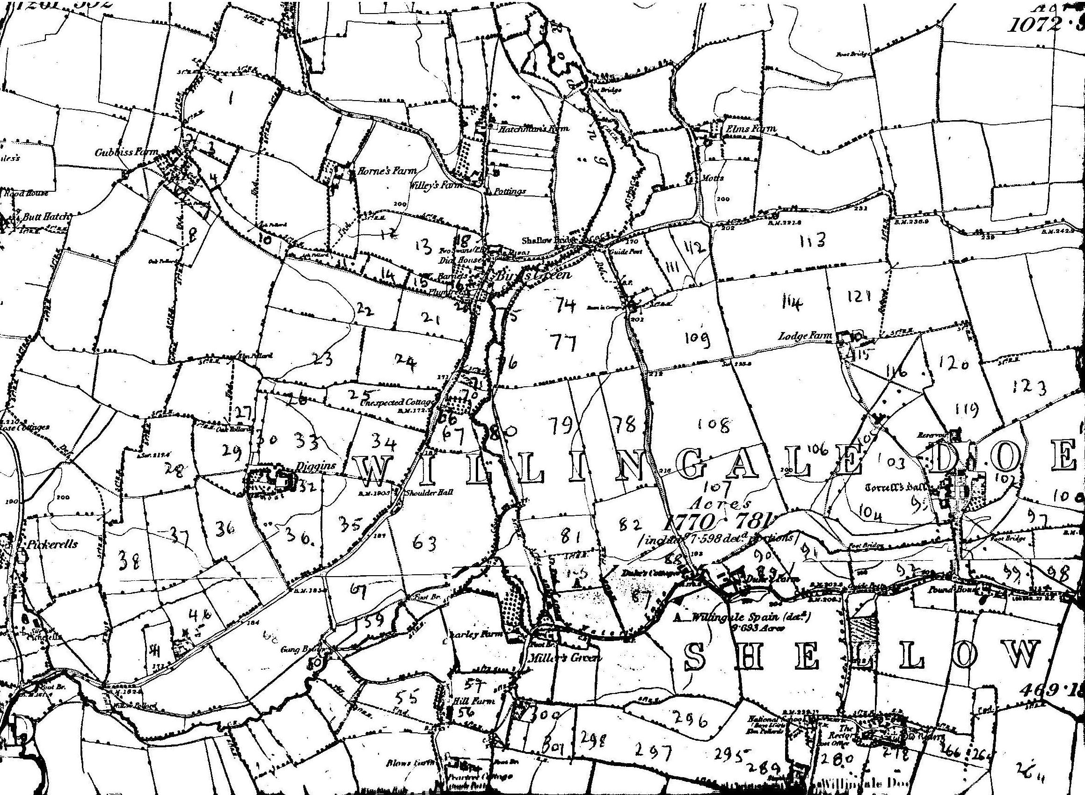
Map 1.
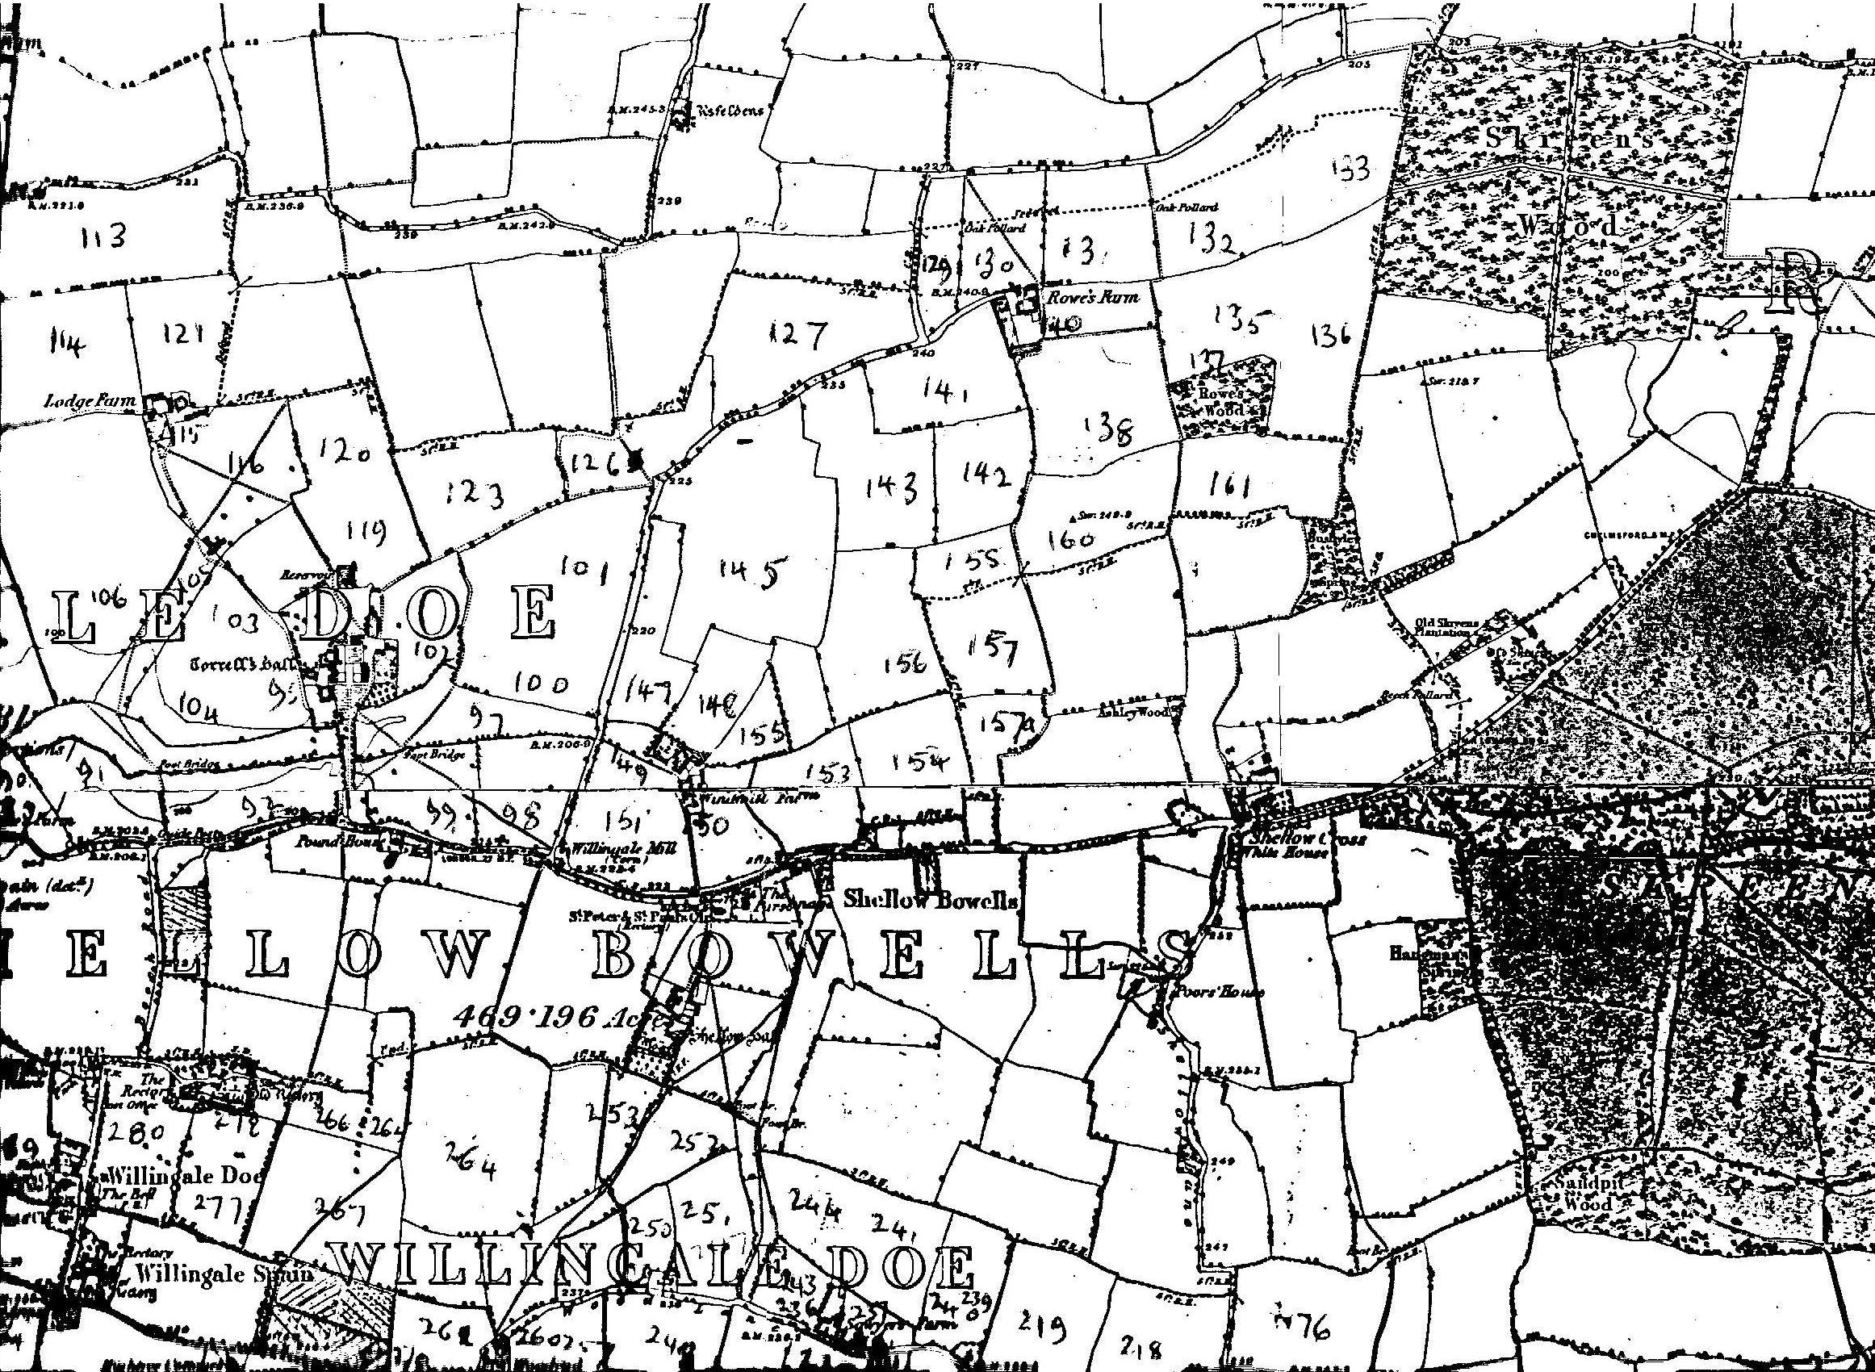
Map 2
Map 3
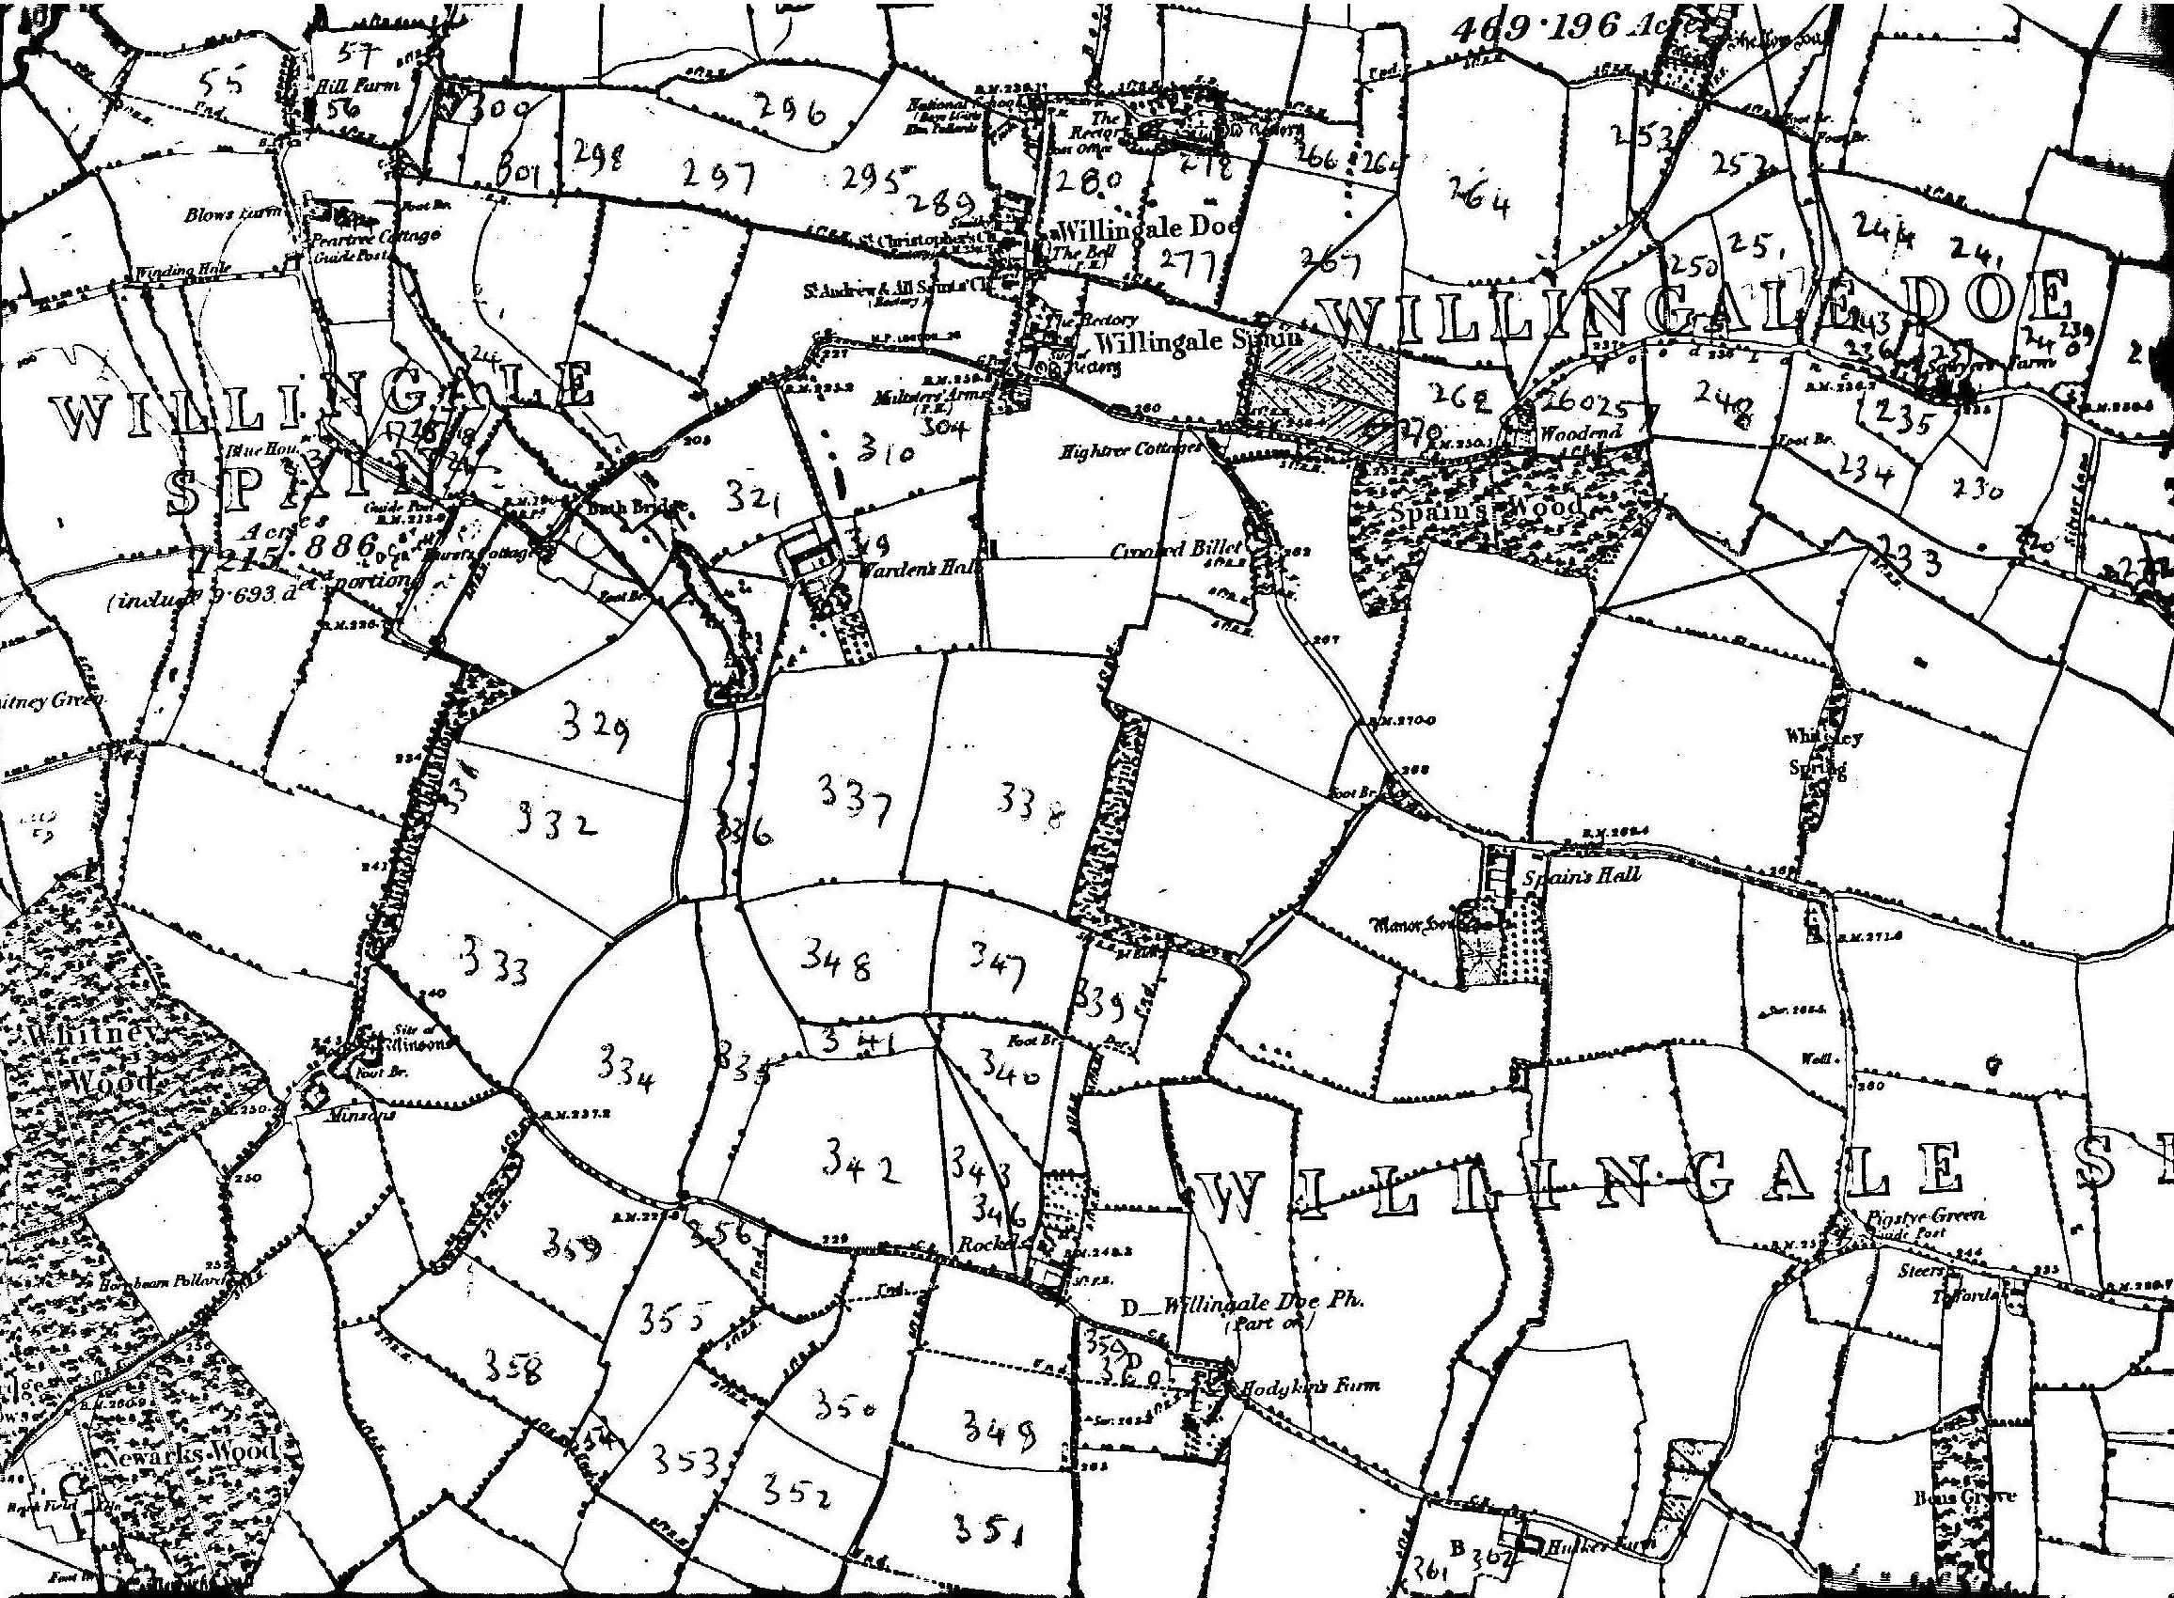
Map 3.
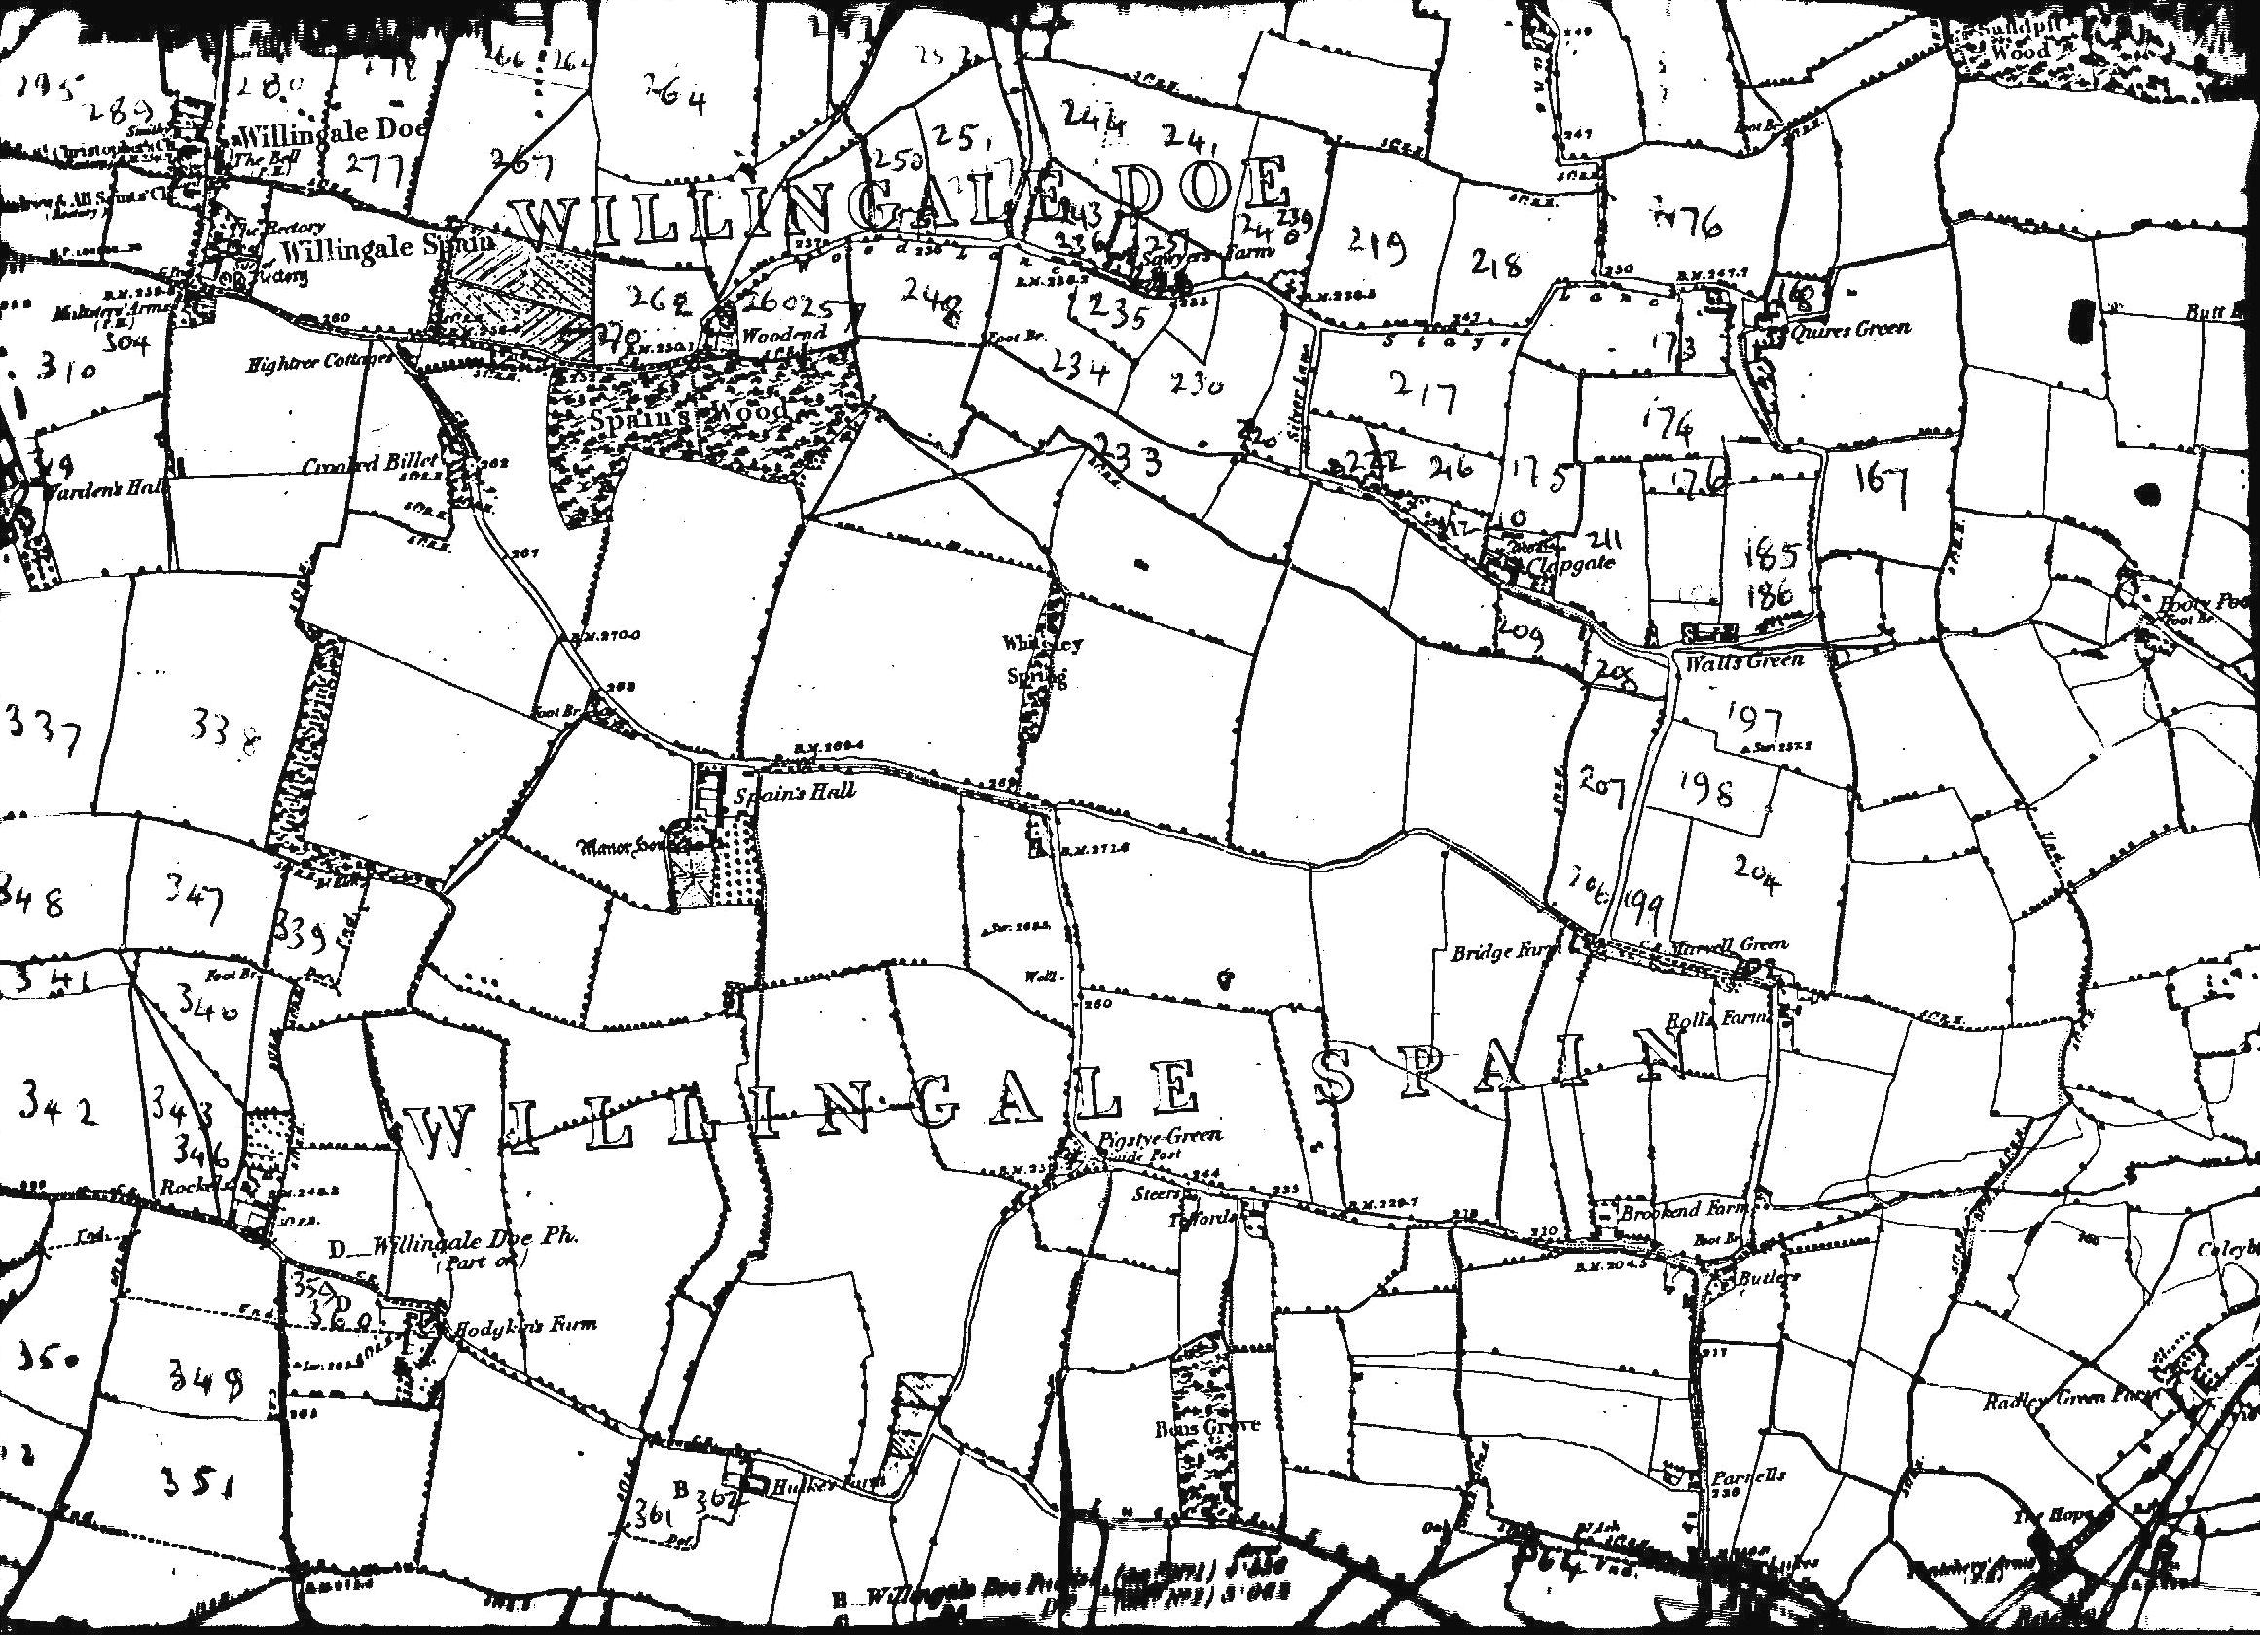
Map 4.

